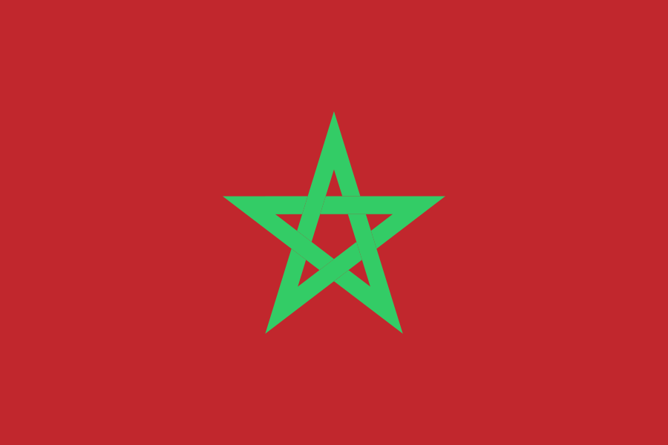 Prohibition of Chemical and Biological Weapons 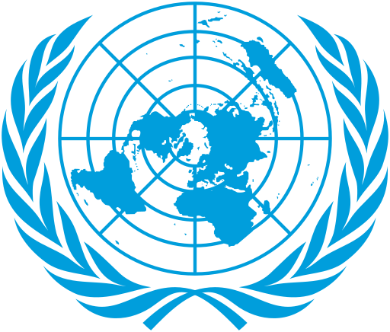
Name: Ege Berk ÇINAR
School: Aydın Doğa High School
Committee: Disarmament & International Security Committee (DISEC)
Delegate: The Kingdom of Morocco
The Kingdom of Morocco, a country with a rich history and strong commitment to global peace and security, stands firmly against the proliferation of mass destruction weapons, especially chemical and biological weapons (CBWs). These are seen as not only a threat to Morocco’s national security and regional stability, but they are also a great global risk. Morocco believes that such tools propose a significant possibility of massacres, inhumane war crimes and other dangerous consequences.

The United Nations has been a key player in addressing the danger of chemical and biological weapons (CBWs) through important treaties, such as the Chemical Weapons Convention (CWC) and the Biological Weapons Convention (BWC). The CWC, which was agreed in 1992 and took effect in 1997, aims to get rid of all chemical weaponry by making it illegal to create, build, get, or even be involved with them in any way. Essentially, the treaty is important in terms of regulating weapons because it eliminates this category of extremely destructive ones. On the other hand, the BWC, which opened for signature in 1972 and has been in force since 1975, prohibits the development, production, and acquisition of biological weapons. Each of these conventions is supported by the Kingdom of Morocco.

Another way the Kingdom of Morocco combats this threat is by collaborating with international partners like the United States of America to get better at finding and dealing with dangers related. Additionally, the Kingdom of Morocco actively participates in international training programs and continuously upgrades its technology to effectively tackle this global challenge.
Because of its geographical location, diplomatic views, and place in history the Kingdom of Morocco faces various dangers caused by neighboring states. The ongoing conflict between the indigenous Sahrawi people and the Moroccan government in the country's Western Sahara region continuously raises tensions in Morocco's diplomatic relationships. The leading problem with this topic is Algeria's support for the separatist group of Sahrawis (or by their self-attributed name, Sahrawi Arab Democratic Republic) which the Moroccan government sees as a terrorist group. As a result of the aforementioned situations, the Kingdom of Morocco believes biological and chemical weapons might potentially be used against them. Therefore, Morocco hopes that the UN will take the necessary precautions.

To sum up, The Kingdom of Morocco wants a strong resolution from the committee that will reassure the complete ban of CBWs and their elimination in addition to promoting teamwork between countries. Current agreements, such as the BWC and the CWC, should be strengthened in order to help nations meet their responsibilities under these agreements. Therefore, The Kingdom of Morocco is committed to working together and following the global standards. It is only through joining forces that the world will be able to combat the threat of CBWs effectively, thus ensuring a safer future.

