MUN POSITION PAPER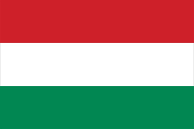

Country:Hungary

Committee: United Nations Educational, Scientific and Cultural Organization (UNESCO)

Topic: Preserving Cultural Heritage

Introduction to the Committee:

UNESCO is the United Nations Educational, Scientific and Cultural Organization.  UNESCO promotes knowledge sharing and the free flow of ideas to accelerate mutual understanding in adition to this  it contributes to peace and security by promoting international cooperation in education, sciences, culture, communication and information.

Introduction to the Agenda Item:

Heritage includes both mobile and immovable, natural and cultural, physical and intangible, and documented assets that have been passed down from the past to future generations due to their priceless value . As a source of identity, heritage is a valuable factor for empowering local communities and enabling vulnerable groups to participate fully in social and cultural life.

Cultural Heritage:

As of 2021, there are eight World Heritage Sites in Hungary, seven of which are cultural sites and one, the [Caves of Aggtelek Karst and Slovak Karst](https://en.wikipedia.org/wiki/Caves_of_Aggtelek_Karst_and_Slovak_Karst" \o "Caves of Aggtelek Karst and Slovak Karst), is a natural site. The first two sites in Hungary were added to the list at the 11th Session of the [World Heritage Committee](https://en.wikipedia.org/wiki/World_Heritage_Committee), held in [Paris](https://en.wikipedia.org/wiki/Paris), [France](https://en.wikipedia.org/wiki/France) in 1987. One of these two sites was the village of [Hollókő](https://en.wikipedia.org/wiki/Holl%C3%B3k%C5%91" \o "Hollókő), the other was [Budapest](https://en.wikipedia.org/wiki/Budapest" \o "Budapest), the Banks of the [Danube](https://en.wikipedia.org/wiki/Danube" \o "Danube) with the district of [Buda Castle](https://en.wikipedia.org/wiki/Buda_Castle) . The most recent site added to the list is the [Tokaj Wine Region Historic Cultural Landscape](https://en.wikipedia.org/wiki/Tokaj_wine_region" \o "Tokaj wine region), listed in 2002Two sites are transnational. [Fertö / Neusiedlersee Cultural Landscape](https://en.wikipedia.org/wiki/Lake_Neusiedl" \o "Lake Neusiedl) is shared with Austria and the Caves of Aggtelek Karst and Slovak Karst are shared with Slovakia

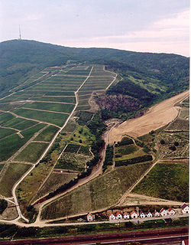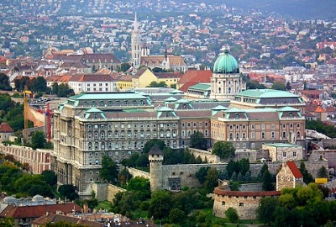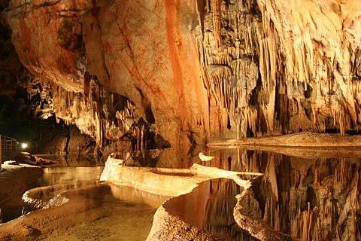

Conclusion:

To be implemented by the Hungarian Open Air Museum, this fifteen-month project aims to develop a methodology for engaging museums with thé Ukrainian communities displaced in Hungary, while supporting the safeguarding of their intangible cultural heritage. The project is based on the outcomes of the UNESCO initiative on community-based needs identification of living heritage safeguarding among displaced communities from Ukraine

Bibliographia:

<https://en.unesco.org/content/preserving-our-heritage>

<https://www.unesco.org/en/brief>

https://ich.unesco.org/en/state/hungary-HU?info=projects