Country: Turkey 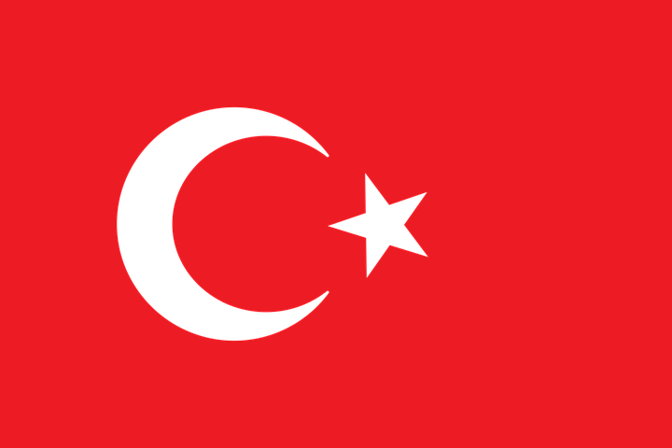Committe: UNEP
Agenda Item: Enhancing the transition to sustainable energy as a response to the energy crisis and climate change

Turkey has prepared for the United Nations Conference on Sustainable Development (Rio+20) assembled in Rio de Janeiro in June 2012, being aware of the fact that Turkey is an actor which should be more sensitive and effective to solve global problems based on its rapid change and development trend, especially in the last decade. Turkey’s Report, entitled as “Turkey’s Sustainable Development Report: Claiming the Future,” is prepared with a participatory and transparent process. With this aim, meetings with broad participation were held both at local and central levels; active dialogues were developed among stakeholders by making use of information and communication technologies. During the preparation process of this Report, particularly Turkey’s experience of sustainable development during recent years is examined with the help of indicators. The reforms realized in the last decade, primarily in economics as well as in environment, education, health, energy and local governments, and advancements in institutional structure in public administration are assessed with a sustainable development perspective. All these changes and developments are complemented by a study in which “best practices” for sustainable development in Turkey are identified. 24 practices out of 181 applications were identified as the country’s “best practices” through an independent evaluation process and are shared with the global community in this report. Those applications make it also possible to indicate the fields in which Turkey is successful and has potential as well as the fields which require more attention. Turkey has realized during its sustainable development process, to reveal the policies which Turkey will apply in the future, to determine its national “vision” and to evaluate the possible contribution of Turkey to solving global problems. In addition, the report intends to determine Turkey’s opportunities and threats in implementing green growth as an instrument for sustainable development, and to discuss the fields in which green growth may contribute to the creation of integrated policies for the economy, society and environment. While determining its “green growth” vision, Turkey has discussed the subject with the representatives of the public and private sector, academia and nongovernmental organizations (NGOs) benefited from researches on this topic as well as its sustainable development experience gained throughout last 20 years. Turkey believes in a “human” centered development. Sustaining the existence of human beings in a strengthened way is only possible by realizing the principles of equity and sustainability. Based on this notion, green growth can only be a meaningful part of the national and international agenda if it presents a more honored life to people. In other words, an economic structure that places more emphasis on environmental values can only be acceptable and applicable to the extent that it contributes increasingly to human development for present and future generations. Turkey will strengthen green growth on her sustainable development path based on its “respective capabilities” in the short term.

