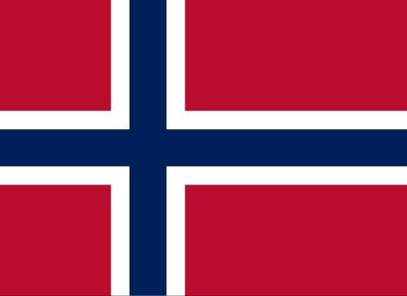

Committee: Social, Cultural & Humanitarian Committee

Agenda Item: Accomplishing Freedom of Press and Protection of Journalists Within Conflict Zones

Country: Norway

Delegate: Yağmur Aral

Norway’s legal framework safeguarding freedom of the press is robust. The media market is vibrant, featuring a strong public service broadcaster and a diversified private sector with publishing companies guaranteeing extensive editorial independence.

The Norwegian media operate in a favourable political environment. By and large, Norwegian politicians refrain from labelling unfavourable coverage as “fake news” and from disparaging its authors. Parliamentarians and government ministers avoid approaching the editorial boards of publications subsidised by public bodies.

On the whole, society and the state encourage independent journalism and the exchange of ideas. Journalists generally work in a safe environment.

References:

https://rsf.org/en/country/norway