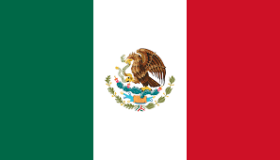

Country: Mexico

Committee: SOCHUM

Agenda Item: Access to Education for Refugee Children

I. Introduction / Background
Mexico sees education as a fundamental human right and one of the most powerful tools to protect refugee children. As a member of SOCHUM, we stand behind the committee’s efforts to raise international standards on child protection, social inclusion, and cultural integration. Given the rising number of displaced individuals in our region, it is more crucial than ever to ensure that refugee children can access education, are not pushed to the margins of society, and are given a fair chance to belong and thrive.

II. Country Position
Mexico firmly believes that refugee children should be included in the national education system, regardless of their documentation status. We have developed policies that allow these children to attend public schools and have implemented supportive programs to help with their emotional well-being and academic progress. Education is more than just lessons and classrooms—it is a shield against exploitation, human trafficking, and social exclusion, all of which are key concerns for SOCHUM.

III. Conclusion
Mexico is fully committed to making education accessible to all refugee children. We are prepared to collaborate with the global community to create education systems that are fair, inclusive, and effective. Providing access to education is not just a legal duty—it is a moral and humanitarian responsibility. It strengthens communities and gives young people hope for a better future. Mexico urges all member states to join forces, share best practices, and support initiatives that ensure every child receives the education they deserve.
References:
www.un.org
www.en.wikipedia.org

