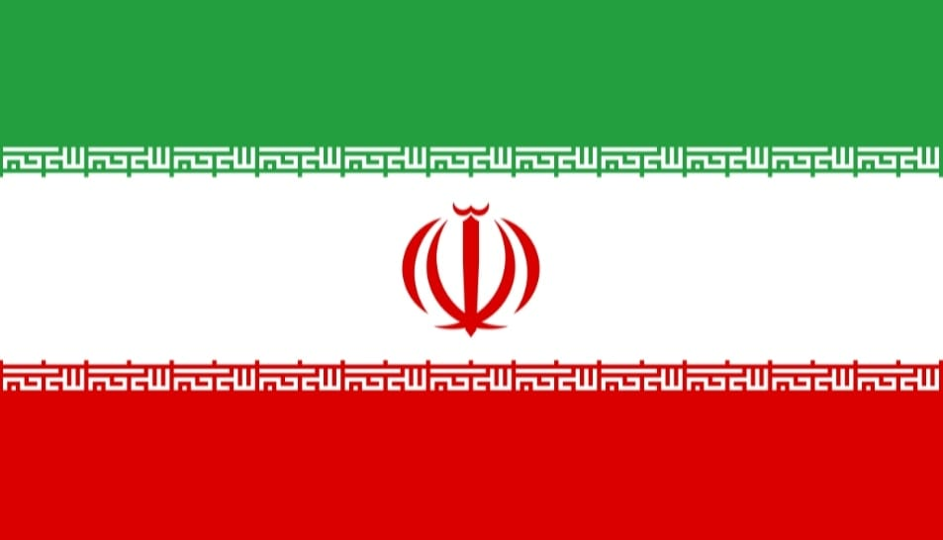Country: Islamıc Republıc of Iran

Committee: UNESCO

Agenta Item: Preserve cultural heritage

Delegate: İrem Ece DORA

The Islamic Republic of Iran is a country located in Southwest Asia. It has land borders with Turkey, Azerbaijan, Armenia, Pakistan, Afghanistan and Turkmenistan. Its capital is Tehran. The official language is Persian. The official religion of the country is Islam. Iran is the 17th most populous country in the world, with about 86 million inhabitants. Ethnically, Persians make up more than half of the population, with Azerbaijanis and Kurds as minorities and Baluch, Turkmen and Arabs in much smaller numbers. Iran's economy is a mix of planned economy, state ownership of oil and other major sectors, rural agriculture and small-scale private business and service investment. The political system of the Islamic Republic is based on the 1979 Constitution of Iran.Iranian culture is diverse and multidimensional. This characteristic is based on historical developments on the one hand and ethnic, religious and linguistic elements on the other. Iranian culture experienced two golden ages in history: one during the Achaemenids and Sassanids and the other during the Islamic period. Both the Achaemenid and Sassanid eras and the Islamic period left great traces on Western culture, especially on Renaissance Europe; the greatest example of this is the introduction of Renaissance Europe to Islamic science and culture through Andalusia. The Iranian scholars brought to the world by the great Islamic civilization are too numerous to count.

There are various threats to Iran's cultural heritage. The most important of these factors are wars and conflicts. Wars and conflicts lead to the destruction of historical sites and damage to cultural heritage. Another factor is theft and illegal excavations. Theft and illegal excavations at archaeological sites can lead to the loss of historical artifacts and damage to cultural heritage. Such activities can lead to illicit trafficking, especially of artifacts recovered from illegal excavations. Other factors can be addressed under the headings of human activities and natural disasters.

Various measures have been taken to protect its cultural heritage against these threats. Some important measures include the following:

* UNESCO Cooperation: Iran cooperates with UNESCO and receives support to protect its cultural heritage in the international arena.
* Conservation and Restoration Efforts: Various projects are being carried out to restore and preserve historical and cultural buildings.
* Education and Awareness: Training programs are organized to raise awareness in society to protect cultural heritage.
* Legal Framework: Iran has established a legal framework to protect cultural heritage and has taken protection measures within this framework.
* Museums and Exhibitions: Valuable artifacts are exhibited and protected in museums and made accessible to the public.

These measures support Iran's efforts to preserve its cultural heritage and ensure its transmission to future generations.