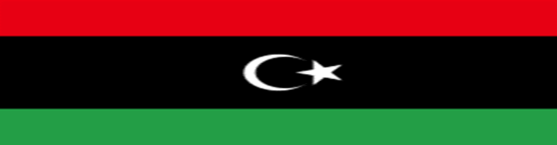

Country: Libya

Committee:UNITED NATIONS EDUCATIONAL SCIENTIFIC AND CULTURAL

ORGANIZATION (UNESCO)

Topic: Preserving Cultural Heritage

Libya is a nation in North Africa, formally known as the State of Libya. The Mediterranean Sea borders it on the north, Egypt borders it on the east, Sudan borders it on the southeast, Chad and Niger border it on the south, and Algeria and Tunisia border it on the west. It has a total area of roughly 700,000 square miles (1.8 million square kilometers). The 17th-largest nation on Earth is Libya. Libya's [borders](https://simple.wikipedia.org/wiki/Border" \o "Border) touch the countries of [Egypt](https://simple.wikipedia.org/wiki/Egypt" \o "Egypt), [Sudan](https://simple.wikipedia.org/wiki/Sudan), [Chad](https://simple.wikipedia.org/wiki/Chad" \o "Chad), [Algeria](https://simple.wikipedia.org/wiki/Algeria" \o "Algeria), [Niger](https://simple.wikipedia.org/wiki/Niger" \o "Niger), and [Tunisia](https://simple.wikipedia.org/wiki/Tunisia" \o "Tunisia). To its north is the [Mediterranean Sea](https://simple.wikipedia.org/wiki/Mediterranean_Sea" \o "Mediterranean Sea). The [capital](https://simple.wikipedia.org/wiki/Capital_(city)" \o "Capital (city)) of Libya is [Tripoli](https://simple.wikipedia.org/wiki/Tripoli), which is a [port](https://simple.wikipedia.org/wiki/Port) on the sea. Tripoli has about one million people. Libya covers an area of about 1,760,000 [km2](https://simple.wikipedia.org/wiki/Square_kilometre) (679,540 [sq mi](https://simple.wikipedia.org/wiki/Square_mile" \o "Square mile)).

On October 13, 1978, Libya ratified the convention.Libya is home to five World Heritage Sites, and an additional three are on the preliminary list.TheLibya now has five World Heritage Sites and three more are tentatively listed. The list was updated in 1986 with the addition of the final site in Libya, following the other three in 1982. Because of their cultural value, all five sites are on the list. The instability brought on by the civil war in Libya has placed all five of these locations under endangered status since 2016.

Libyan cultural legacy needs to be preserved in a multifaceted way. These assets can be protected by putting in place community participation programs, utilizing technology for documentation and teaching, and working with international organizations. A complete solution would also include tougher laws against illicit excavations and the trafficking of artifacts, as well as increased public understanding of the value of cultural preservation.