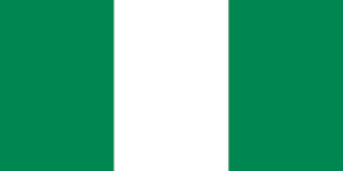
Committee: Un Habitat
Country: Nigeria
Agenda İtem: Building Sustainable and Smart Cities of
the Future

The capital of Nigeria is Abuja. The currency is Naira. Its population is 237.527.782 people. The official language is English. Its area is 923.768 km2 . It is located on the African continent. Nigeria’s form of goverment is the Federal Republic. Nigera consists of a total of 36 states and capital regions. Nigeria is governed by the presidential system. Education in Nigeria is managed by the Federal Ministry of Education. Nigeria’s education system is kindergarten, primary school and secondary school. Healthcare in Nigeria is the responsibility of the three-tier government in the country. Nigeria’s healthcare majors are traditional medicine and alternative medicine.

Sustainable buildings are structures that use nature protecting, resources efficiently and saving energy. It appeared in 1970. Nigeria joins Be Bold On Buildings project for sustainable buildings. The general purpose of this project is to build savings buildings. Green Building Council Nigeria finds solutions to Nigeria’s problems related to sustainable buildings. Green Building Council Nigeria is a non-governmental organization.

Nigeria uses Nationally Determined Contribution policy for sustainable buildings. The
construction and construction sector accounts for a large part of energy consumption globally. Therefore, sustainable buildings are better managed by Nationally Determined Contribution.

