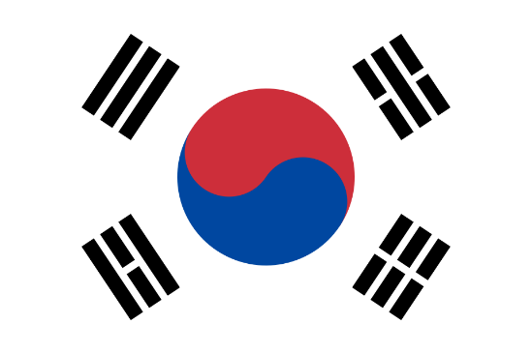
COUNTRY: SOUTH KOREA
COMMITTEE: FAO
AGENTA ITEMS: REDUCING GLOBAL HUNGER THROUGH SUSTAINABLE AGRICULTURE

South Korea is located in East Asia. It is on the southern portion of the Korean Peninsula located out from the far east of the Asian landmass. It is a major non-Nato ally of the United Stated. Seul is the capital of South Korea. Its population is estimated at 51 million people. As a nominal, It has the 4th largest economy in Asia. Concurrently with this ıt has the 13th largest economy in the world. South Korea has been affected by climate change. It affects that social, economy, industry life

In South Korea, there are surplus of agriculture foods. In addition with this situation FAO’s flagship report that many families in South Korea cannot manage a healthy diet and high prices of products have made things harder. In FAO’s latest ‘Hunger Map’ shows that about 673 million people face to face with hunger. It means that many people cannot find foods. This is explosive problems of world starvation. Throught history, various segments of the global population have experienced maintained challanges in securing adequate access to food. In many situations, hunger happened because food supplies were distrupted by war, diasease, or bad weather. Climate change have affected food security. Food security is that people have access to healthy, safe food for healthy life.

The Food And Agriculture Organization of the United Nations (FAO) reports that leads global efforts to address hunger and promote improved nutrition and food security for all. We work with 130+ countries and we collocate with the other countries to solve food problem. Our purpose is increasing of nutrious food, products of food. Even if climate change have extremely affected finding safe food, sustainable agriculture helps people grow better food

