Country: Afghanistan
Committee: SPECPOL
Agenda Item: Reconstruction and Development in Post-Conflict Regions
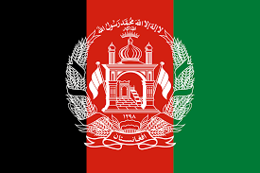

Afghanistan,offically known as the Islamic Emirates of Afghanistan , is a landlocked country located in the South of Central Asia İts capital is Kabul, and its currency its the Afghan afghani The official languages are Pashto and Persian The population of Afghanistan is 42 million and 650 thousands The country’s is among the lowest in terms income per capita There are 15,709 schools across the country, and %36 of these schools do not have a proper building In other words, educatıon has not been fully supported In Afghanistan, healthcare was almost nonexistent due to the civi war and mass migration in the 1990s,but it has been steadily improving in the last decades
The theme of reconstruction has been studied since the 19th century. The first post-war reconstruction effort in history was carried out in Australia following the end of the First World War. It would not be accurate to officially describe us as having been colonised in this regard. However, during the First World War I, we played a buffer zone role between the great powers. After the war, with the intervention of the United States, we developed ourselves with a new constitution, investments in education and health, and forces to ensure the country's security, but this did not have a strong impact due to internal turmoil
In my opinion, countries with signifant authority should assist us in this matter, as well as in education, health, and material and spiritual matters It may be possible to bring to life the urban planning projects will be developed by the urban planner trained in our country’s evolving education system Homever the reconstruction of a country is not limited to buildings; innonative approaches such as preserving a country’s ethics, values and natural beauty also contribute to its reconstruction Therefore, it is also our duty to protect these characteristics

