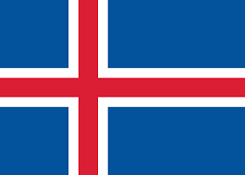
COUNTRY: Iceland
COMMİTTEE: WFP(World food programme)
AGENDA ITEM: Ensuring food security for children in
emergencies

Iceland is a small island country in North Europe. İt is a parliamentary republic. About 380,000 people live there. Education and healthcare are free. The country’s economy is mostly based on fishing.
Food security for children in emergencies means that children can get enough healthy food during disasters. In the past, disasters and conflicts made many children suffer from hunger. Today, climate change makes this problem worse. Because of this, the WFP works with countries to find solutions. Iceland supports teams that can go to disaster areas quickly and Iceland proposes nutrition and hygiene programs for children and then Iceland recoments projects that protect food supplies and also Iceland encourages safe drinking water projects.
Iceland understands that climate change is harmful for food security. Changing weather makes farming and animal production difficult. Because of this, Iceland believes that fighting climate change is important for children’s future. As a result ,Iceland proposes a plan to help children during emergencies and clean water. Sending water filters and purification devices to disaster areas Iceland believes that early warning systems that Using technology to detect disasters early and storing food in risky areas should be used.

