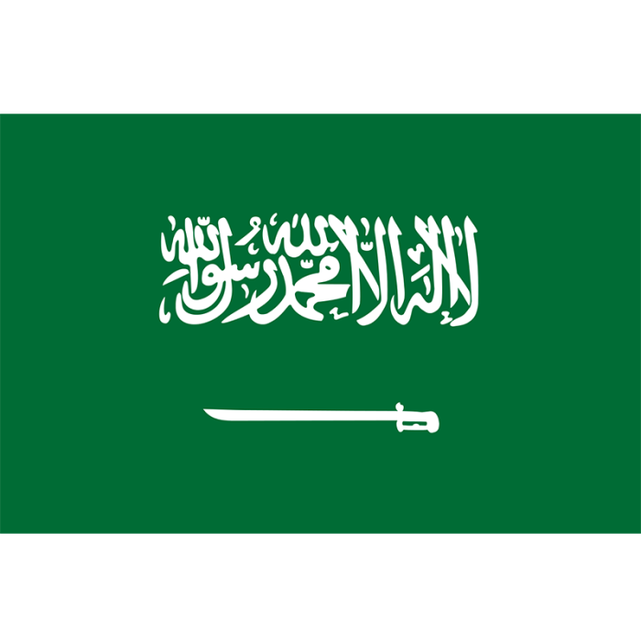
Delegation:The Kingdom of Saudi Arabia
Committee:United Nations Entity for Gender
Equality and the Empowerment of Women
Committee (UNWOMEN)
Agenda Item: Strengthening protections
around women’s fundamental rights in the MENA region

Saudi Arabia is located in West Asia, bordering the Persian Gulf and the Red Sea. It has borders with Jordan, Iraq, Kuwait, Qatar, the United Arab Emirates, Oman, and Yemen. Saudi Arabia covers an area of 2.150.000 km², with a population of little more than 35 million. The official language of the country is Arabic. It is one of the most populous countries in the region, relatively due to its size, and plays a significant role in regional affairs. With Makkah and Madinah being huge cultural and religiously significant features of the country. Saudi Arabia is a major non-NATO ally and a great UN member between other states. The main economic income is from the petroleum sector.

It is an undeniable fact that the violent dominance against women and girls keeps growing and getting worse, which leads women and children to feel even more repressed, and men to feel even more powerful and upstanding negatively against women and children who can’t even stand up for themselves due to the law not being fair to them. As the world continued to evolve, the need for unnecessary patriarchy over the sectors and even the basic places like schools, hospitals, and furthermore, the public places open for all. Providing equal, balanced, and fair rights for both genders has always been an issue, as men have always seen it as a competition and superiority since the beginning of time. This problem has always been around, and it only became worse with technology. Women and girls who live in the MENA regions mostly have no access to even the media to talk about the daily struggles that are imposed on them by their superior male “guardians” and other men. This gender inequality that is reflected in women and young girls is becoming even more serious as they are even facing problems with being provided education, nonetheless hygiene products, as it is seen as shameful. However, this should have never been seen as shameful or anything, and countries and governments, and mostly the law, should see women and men as equals and give them their basic rights without being looked down on. This could be done by removing legal provisions that discriminate based on gender as in laws that restrict women’s rights in marriage, divorce, custody or even inheretence. Saudi Arabia started to realise the effects their culture and unfair laws had on their women and young girls as they started to work on their laws and legal frameworks. Culture is not easy to erase or replace and it might take time to break the unhealthy sides of them but Saudi Arabia is trying.

To conclude Saudi Arabia recognizes the strenghtening protections around women’s fundamental rights in the MENA region and acknowlegdes the issues and the problems women and young girls face in the MENA region just for their gender that they were born to. Saudi Arabia will continue to support the efforts trying to equalise both genders and provide both with equal basic human rights and advocate for the healthy social community in their country and for us all.

BIBLIOGRAPHY
https://data.unwomen.org/country/saudi-arabia

https://en.wikipedia.org/wiki/Saudi_Arabia

https://en.wikipedia.org/wiki/Women%27s_rights_in_Saudi_Arabia#:~:text=The%20laws%20also%20extend%20employment,senior%20ranks%20of%20the%20military.

https://arabstates.unwomen.org/en/digital-library/publications/2021/11/situational-analysis-of-women-and-girls-in-the-mena-and-arab-states-region

https://theweek.com/60339/things-women-cant-do-in-saudi-arabia

