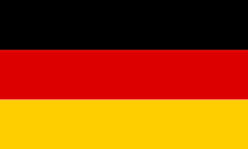**United Nations Economic and Social Council (ecosoc)**

**Country: Germany**

**Topic:**   **Economic Policies Supporting Sustainable Development**

Germany is one of the leading countries in the world, both in economy and influence. Germany prioritises green energy and sustainable, renewable energy over natural resources like coal and natural gassesand is ready to act to save our planet from a dark future, signing multiple agreements to save our planet, like the Paris Agreement and more agreement to limit the output of .

Climate change and the future of our planet are two of the most important problems currently affecting all of us, with the climate being affected even by the smallest things that we use or have a significant role in our lifes, like perfumes. Deodorant to ships, factories, and the vehicles being used insted of public transportation and energy resources like coal and gasoline; natural gas is used for energy production, which is a total of 40 percent in Germany. The green energy use is 60 percent lower than it should be, and the other countries are no different but worse. We as all countrys should make a full turn to green energy as soon as possible

In conclusion, Germany iscommitted to making a big change to green energy, leaving most of the natural resources behind. Germany believes that The world has to collaborate, and people need to be taught recyling how to lower their carbon footprint and their their effect on climate change and the flora of the world to prevent global warming. Thus, Make the future of humankind safe and bright.