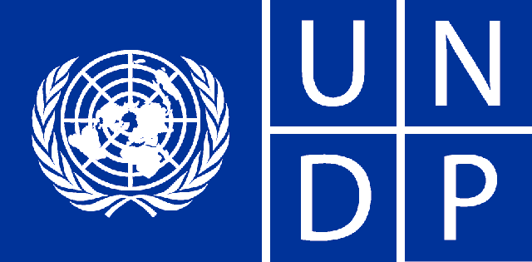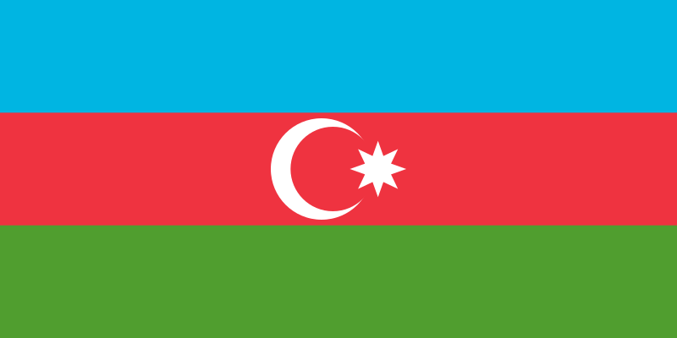

**Country: Azerbaijan**

**Committee: UNDP (The United Nations Development Programme)**

**Delegate: Mehmet Buğra Karakaya**

**Position Paper**

**Agenda Item 1:** Quality Education Interruptions Due to Territorial Disputes in the Middle Eastern and Northern African (MENA) Region.

**Agenda Item 2:** Development of Nuclear Energy and Its Effects on Environmental Matters.

Azerbaijan is a republic with a semi-presidential system. The president usually acts as the head of the government. The political environment in Azerbaijan has become complex due to disagreements over the Nagorno-Karabakh region and internal political competition.Azerbaijan is a country in the Middle East with an economy largely dependent on energy incomes. Oil and natural gas serve as the main sources of income for the country. In recent years, the government has made efforts to expand the economy by investing in sectors such as farming, tourism, and transportation. The population of the country is about 10 million people, with the capital city, Baku, being the most populous city and the economic center. While the majority of Azerbaijan's population is made up of Azerbaijanis, there are also other ethnic groups present in the country.

We involved in many projects supported by the United Nations Development Programme (UNDP). These projects generally focus on sustainable development, poverty reduction, environmental protection, education, and health. The agreements signed between the Azerbaijan government and UNDP classically relate to the financing, application, and monitoring of these projects. Additionally, we may also participate in UNDP's regional or global programs.

UNDP and we are working on a supportable rural development project in our country. This project aims to improve the living conditions of communities in rural areas of Azerbaijan. Within the scope of the project, important developments are planned in areas such as farming, substructure, education, and health. Farmer training and technical support will be provided to increase farming production and marketing capacity, while rural organisation will be improved to meet basic needs such as water supply, roads, and electricity. Additionally, schools and education centers will be established or improved to raise the education level of rural communities’, and health centers will be established and health personnel will be trained to increase access to basic health services. Among the outcomes of this project are expected to be important improvements in income levels and living conditions of communities in rural areas, increased agricultural production, addressing infrastructure deficiencies, and improved access to education and health services. This project is expected to make important contributions to Azerbaijan's rural development.

UNDP has started another project to increase Azerbaijan's solar energy potential. Within the scope of this project, the installation and use of solar energy systems are encouraged, aiming to make supportable energy sources more accessible to bigger number of users. Additionally, education and consciousness activities on solar energy technologies are organized, simplifying local communities’ access to these technologies. This project aims to meet Azerbaijan's energy needs while reducing environmental impacts and increasing the use of renewable energy sources.

**Bibliography**

*Mustafayev , F., Kulawczuk, P., & Orobello, C. (2022). Mustafayev, F., Kulawczuk, P. ve Orobello, C. (2022). Renewable energy status in azerbaijan: solar and wind potentials for future development. Energi̇es, 1-24. ENERGIES, 1–24.*

*Vidadili, N., Suleymanov, E.,   Bulut, C., & Mahmudlu, C. (2017a). Transition to renewable energy and sustainable energy development in Azerbaijan. Renewable and Sustainable Energy Reviews, 1154–1161.*

*Heinrich, A. (2011). The Political System in Azerbaijan. ETH Library, 1–21.*

*Hasanov, F. (2008). DUTCH DISEASE AND AZERBAIJAN ECONOMY. Working Paper Series, 1-21.*

[*https://www.undp.org/azerbaijan?search=azerbaijan*](https://www.undp.org/azerbaijan?search=azerbaijan)

[*https://www.undp.org/azerbaijan/our-focus*](https://www.undp.org/azerbaijan/our-focus)