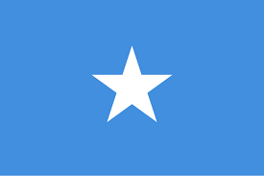
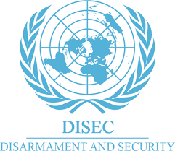

COUNTRY: FEDERAL REPUBLİC OF SOMALİA
COMMİTEE: DİSEC (DİSARMAMENT AND İNTERNATİONAL SECURİTY COMMİTEE)
DELEGATE: Yağız Alioğlu
Position Paper

Agenda İtem 1: confronting the threats to Merchant shipping: the rise of weaponized drones and terrorism at sea.

Somalia is the eastermost country in Africa, stretching across the horn of Africa. Somalia has a population of 18.1 million , 2.7 million of the population live in the capital and the largest city, Mogadishu. Somalia is a sunni muslim country and the main language is Somali and Arabic.

We, as somalia, think that weaponised drones and the sea terrorism are a big threat for humanity. As our country fought against piracy we deeply believe that the sea terrorism and the weaponised drones should be controlled. We solved sea piracy with global cooperation and we should show the same determination.

As somalia we deeply consider that modern weapon systems make seas more dangerous so it can effect countries economies and it could cause them to enter an economic crisis. We are looking forward to solve these problems with possible collaborations that will help every county that is suffering these problems. We truly believe with collaborations and helps from the other countries together we can solve this problems and have a nice future.

Bibliography:
https://en.wikipedia.org/wiki/Somalia
https://www.imo.org/en/MediaCentre/Pages/WhatsNew-1953.aspx

