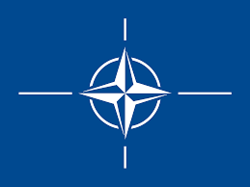

Committee:North Atlantic Treaty Organization (NATO)
Country: Republic of Lithuania
Delegate: Ramazan Kürşat Gülmez
Agenda:Addressing the Strategic Implications of China’s Expanding Global Influence
Position paper
China’s Expanding Global Influence The republic of Lithuania commited to international peace and democracy and the rule of law however the rapid growth and military pover of peoples republic of china poses a serious
We had experience before to get politcal pressure from china after we established politcal relations with taiwanese government

We think china’s expanding global economic power is a serious issue for the European country’s and economy of our world and we should reduce dependency on Chinese technologies, particularly in telecommunications 5G and artificial intelligence by researching more different ways to make it easier and less cost-effective

And we should reduce the usage of china’s by make our under water etharnet cables to prevent china’s cyber attacks defense ourselves from china and we should train more people for cyber attacks and we should train more people to become cyber soldiers to counter attack china when its time.
We need to find new raw sources and technology to get independent from china’s economy and distribution and remove china’s economy as possible NATO members should screen chinese apps such as tiktok,taobao,wechat,meituan for malwares

Bibliography
https://www.britannica.com/place/Lithuania
https://tr.wikipedia.org/wiki/%C3%87in-Litvanya_ili%C5%9Fkileri

