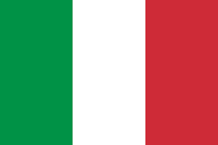
Country: Italy
Committee: UNICEF (United Nations International Children's Emergency Fund)
Agenda Item: Preventing Child Trafficking in Third World Countries

Italy is located on the Southern Europe and 23rd biggest country in the world by the population. Italy has been a part of UN since 1955. Italy’s border neighbours are Austria, France, Holy See, San Marino, Slovenia and Switzerland. Government system is republic. Italy is the eighth biggest country in the world GDP ranking. Italy is a popular tourist destination because of its culture and worldwide known cuisine.

Child trafficking is a big problem for the world. In Italy, the children who are trafficking are coming from abroad; mostly from Africa. In 2016, the top ten countries of origin of these trafficked children were Eritrea (15%), Gambia (12.5%), Nigeria (12%), Egypt (9,5%), Guinea (9,3%), Ivory Coast (6,7%), Somalia (6%), Mali (5,4%), Senegal (4,5%) and Bangladesh (4%). For this issue, since UNICEF’s establishment Italy government has been working with UNICEF. Moreover, UNICEF Italy is the third biggest support of the UNICEF.

As the Italy Republic, we really want to solve this issue for the children who does not have a peaceful childhood. Our aim for this conference is to solve this issue with the best way.

