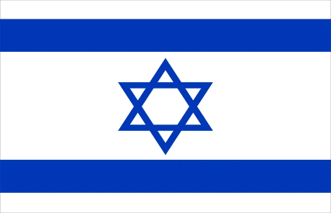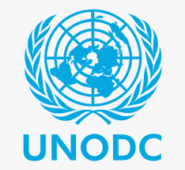
Country: Israel
Committee: UNODC
Delegate: Nehir Arı
AGENTA ITEM I : Strengthening Crime Prevention Frameworks In Marginalized Neighbourhoods Through Community Based Interventions
AGENTA ITEM II : Addresing The Security Risks Arising From Urban Infrastructure Deficits In Vulnerable Countries
Israel is located in the Middle East, along the eastern coastline of the Mediterranean Sea, bordered by Lebanon, Syria, Jordan and Egypt. Israel’s public sector is a large and high-quality sector. According to the Government Companies Authority report (2020). In Jureselam 35,900 people were employed in, Jureselam public, admistration and defense in the Compulsary Social Security.Which shows that employees are in a high rating, and that makes crimes become less active in our country. Crime prevention starts with gaining a trust in the country, in the president. People are having no hope in theirselfs or in their country that’s why they are searching for a gun, a way of committing a crime. They are not educated well in school. In our country our people are well educated with Torah. Success, safety and trustability is not a coincidence. We are making our people, people born in our lands, grassroots initiatives to believe in our policy, our root judaism. There is no constitution in Israel. But our people are connected, our people know their policy. Constitution isn’t everything.

In prisons, we are planning on building religious areas for criminals because if you can’t let a guilty person to fix, then everything will be the same. On the other hand, rehabilitation will be given for people who needed. The right of seeing a doctor, having a medicine is what we need our people for getting them back to our enviroment. We can not accept a criminal. Instead we have to gain them back to our lands. Giving them the military education in prisons. Especially if they are Arabian or Muslim, they will get the military education and will be forced to be in armies. Youth Engagement Programmes will be şcontributed by UNESCO since they are international and can be a road for communicate with all countries. Primary, Secondary and Tertiary crime prevention plans will be our leaders in every case. Primary prevention plan will help us find the criminals employment situtation,childhood education and family backround. Secondary prevention will be more effective on people because family support services and realizing the communities on the streets are an effective prevention. Cameras will be in every street and will make people feel safe and will scare groups such as drug dealers. Tertiary prevention is the most important one sinc we’ve talked about gainging people and strethend social network programms for youth. Using Community Based Intervantions will treat people who are jewish, equally. Public and prive partnership will guide every country since our country unfortunatly not trusting public partnership, but will give the countries the public trustability, and with Non Govermental Organizations (NGOs), foundations, Civil Society Organizations (CSO). Socio economic problem sor the issiue of being a migrant will not be problem since we are planning to welcome only migrant children for educate them. We cannot welcome any Arabian people but this will not be an obstacle because every country will agree on, their culture is discriminating every person on earth.

Security in urban infrastructive is also an important problem for Israel since we were a vulnerable country in history, our streets are filled with pride beauce Israel has always been very caring about human rights. Lightnings on the streets are very low and we are aware of that and will held that with the support of, UNDP. They are countries in our earth which cannot even reach the water, the healtcare needs, the food. And they are not safe from natural disasters. We are hoping to reach them via NGOs, Sustainable Urban Development, and Disaster Risk Reduction (DRR). Financing the NGOs with sustainable loans, taxes from people by gaining their trust with good advertising that comes from representatives of each state. Also getting the need from World Bank, Ecofin, UNDP and Public and Private partnerships (PPPs) The buildings, the slums are in high price and static poor even tho they are mobile elit. The sale of basic needs are making people illegal people when people cannot reach their basic needs, everything is illegal because the president, the representative don’t even know their people who live in Blackout Zones. Reaching them with local polices and using the dangerous groups of people on the streets for education and then gaining their trust and give them the wagers and suppies will help us reach the unknown people and also gaining the dangerous people into enviroment and teaching them Toran for a constitution.
BIBLOGRAPHY / REFERENCES
https://www.britannica.com/place/Israel/History
https://urban-future.org/event/helsingborg-22/organisations-ngos/
https://www.gov.il/en/departments/topics/detention_and_corrections/govil-landing-page
https://www.timesofisrael.com/daily-briefing-jan-22-day-839-report-exposes-unfit-jail-conditions-for-palestinian-offenders/
https://moderndiplomacy.eu/2025/06/24/europes-blind-spot-the-israel-iran-war-and-the-coming-refugee-surge/
https://www.thetimes.com/travel/advice/is-it-safe-to-travel-to-israel-right-now-80hw9793n

