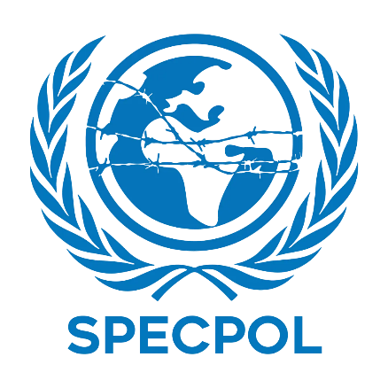
 | SPECPOL CANADA POSİTİON PAPER | 
Comitee:Specpol
Country:Canada
Topic: Reconstruction and Development in Post-Conflict Regions
Several communities reside in Canada, a calm and peaceful nation. Life in Canada is considered serene, and people feel secure. For this reason, we recognize the value of assisting people who have been victims of war. Canada collaborates with the UN and advocates for the right to education, human rights, and peace. When a war finishes, the problems certainly do not. Losing homes, children not being able to attend school, and a complete lack of clean water for the people are all realities. Canada has the experience to know that the process of rebuilding lost trust and took time. Delegation of Canada is ready to work with other countries and UN.

Canada has been assisting countries such as Haiti and South Sudan by rebuilding schools, installing water systems, and providing adequate training to local staff. For Canada, rebuilding means so much more than constructing new structures and mitigation of the visible problems. For the people, it is about providing a tangible sense of safety and hope that the government and both local and global communities are caring and involved. Canada has witnessed this in numerous areas and is determined to ensure more equitable rebuilding for the future. Rebuilding processes need to be handled the right way and Canada values economy, efficiency and transparency. If funds are abused, people become disillusioned. Canada calls for coordinated action from the UN, political leaders, and civil society, rather than unilateral action.

Canada has proposed three initiatives. Local Leadership
- Educational and community ownership through the participation of youth and women in rebuilding. Green and Safe Infrastructure
- The construction of schools and housing should use renewable energy and be made from climate friendly building materials. Digital Learning Corners
- Setting up small learning hubs in areas where schools are destroyed allows children to continue their education. Canada is willing to contribute to the positive peace effort, share their experience, and cooperate with other nations.
Canada’s ultimate aim is to give children from conflict-affected areas the protection to go to school, and to dream their hopes for the future. The building of peace. What Canada Wants. First and foremost, Canada believes in restoring the essential humanitarian needs of the people first. Clean and accessible water. Shelter. Safe housing. Schools. Families become more at peace and conflict is reduced when these basic humanitarian needs are met.
Bibliography:
1. Global Affairs Canada – International Assistance
https://www.international.gc.ca
2. Government of Canada – Canada’s Engagement in Haiti
https://www.international.gc.ca/country-pays/haiti/relations.aspx
3. Government of Canada – Canada’s Support to South Sudan
https://www.international.gc.ca/country-pays/south_sudan-soudan_sud/relations.aspx
4. United Nations Peacebuilding Commission
https://www.un.org/peacebuilding
5. United Nations Development Programme (UNDP) – Crisis Recovery
https://www.undp.org/crisis-recovery
6. UNICEF – Education in Emergencies
https://www.unicef.org/education/emergencies
7. World Bank – Fragility, Conflict & Violence
https://www.worldbank.org/en/topic/fragilityconflictviolence
8. OECD – Fragile States and Development Co-operation
https://www.oecd.org/dac/fragile-states/
9. United Nations – SPECPOL Committee
https://www.un.org/en/ga/fourth

