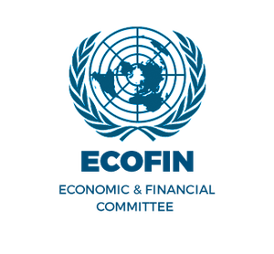
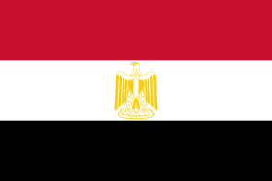
POSITION PAPER

Country:Egypt
Committees:Economic And Financial Affairs Council Configuration
Agenda: Promoting the Green Economy and Renewable Energy Investments
Primary, we believe that our country, Egypt has sufficient renewable energy resources. For example, we have power plants in many energy branches, such as green hydrogen, which we started in Egypt, or wind and solar energy. The Arab Republic of Egypt strongly supports global efforts toward building a sustainable and green economy through the promotion of renewable energy. As a developing country with large natural capacity, Egypt recognizes the importance of transitioning to cleaner energy sources while supporting economic growth and job creation.
The Arab Republic of Egypt supports the global shift towards a greener and more sustainable economy. As part of its national strategy, Egypt is investing in renewable energy, especially in clean technologies like green hydrogen and wind energy.
Green hydrogen is produced using renewable electricity and does not emit harmful emissions. Egypt has launched projects in this area in key areas near the Suez Canal. These efforts aim to make Egypt a leader in clean energy in the region.
Wind energy is another important form of Egypt's energy future. The country is working to increase its wind energy capacity and reduce its dependence on fossil fuels.
We believe that international cooperation and green investment are vital to investing in a better and cleaner future. Egypt is poised for clean energy development and a stronger green economy.

bibliography
https://gh2.org/countries/egypt

