
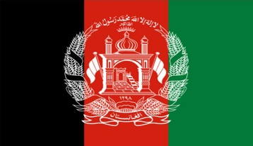

POSITION PAPER — UNICEF

Delegation: Afghanistan Committee: UNICEF

Topic: Banning Secondary Education and Post Secondary Education For Girls
Girls Right to Post-Middle School Education Has Been Banned in Afghan Schools.
After 20 years of war in Afghanistan, new government came to power in 2021. The peoples damaged by the war by the strict interpretation of new government Islamic law into practice again. Girls' access to secondary education is prohibited. This decision continues to damage the future of millions of Afghan girls. If the ban continues, more than four million girls will be deprived of the right to post-primary school education.
United Nations Assistance Mission to Afghanistan (UNAMA), He cancel the Taliban's call to end its "unfair" ban on the education of girls.
The UN (United Nations) reminded the restrictions on women and did not accept the request to represent Afghanistan in the international organization. Foreign countries did not officially recognize Afghan rulers due to human rights concerns.
Afghanistan's new school year begins, it has been more than 900 days since girls aged 12 and over went to school and university," he said in a statement on the social media platform X.
UNAMA calls on the de facto authorities to end this unjust and harmful ban. Education is indispensable for everyone, peace and prosperity," he wrote. If this ban continues, it will negatively affect the health system, the country and the economy. Since fewer girls are educated, girls face the risk of child marriage.
There will be a shortage of female health personnel in the country. This will endanger lives. With the decrease in the number of female doctors and midwives, girls and women will not receive the medical treatment and support they need. These represent lost lives and broken families. All girls should be allowed to return to school immediately.

Talented and intelligent young girls should be educated. Afghan children should be offered their education rights equally, regardless of whether they are girls and boys. We will continue to defend the right of every Afghan girl to education, and we call on the actual authorities to immediately lift this ban.

BİBLİOGRAPHY
- https://www.unicef.org
- https://www.voanews
- https://devpolicy.org/the-continuing-ban-on-girls-education-in
- https://unama.unmissions.org

