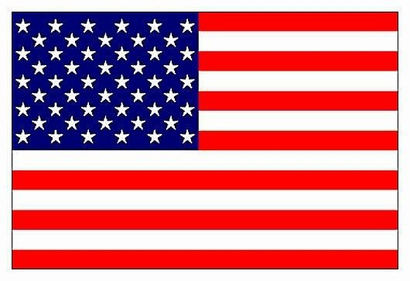
Position Paper

Committee: Social Humanitarian & Cultural Committee (SOCHUM)

Topic: Ensuring Access to Education for Refugee Children

Country: The United States of America

Located between Canada and Mexico, governed as a federal constitutional republic, the United States is the fourth largest country by land area with a population of 334 million. Its strong economy, based on information technology, exports and underground sources; advanced technology and egalitarian attitude made it one of the most powerful and advanced countries in the world. Additionally, the USA has always been very active as a peacemaker and always has a say in international matters, so it plays a key role in the UN. By this means the USA is always in cooperation with SOCHUM to reach a solution for refugees’ problems, one of which is to be addressed immediately. That is access to education for refugee children. If there are still thousands of refugees around the world who are unable to receive an education for various reasons, it becomes a significant problem causing domestic insecurity, low standard of living and many other problems.

Due to refugee crises, particularly the 2015 one, currently there are more than 120 million refugees in the world and children make up %50 of them. Most of the refugees are from Syria, Afghanistan, DRC (Democratic Republic of the Congo), Somali and Sudan. However, only %51 of them have enrolled in primary school, %38 have gone to secondary school and only %6 have reached high school level. Compared to global average, refugees have approximately %67 less access to education than countries’ citizens. That’s well below average and unacceptable. For this purpose, the USA government has enacted laws like the Refugee Act of 1980 (RA), Displace Persons Act of 1948 and Immigration and Nationality Act (1952) to protect refugees rights including education. Driven by those laws, the USA has given financial, linguistic and psychological supports with EL, ORR, University-Based Sponsorship programs for refugees and information programs for teachers. As a result, the USA provides more than %70 of educational opportunities for refugees.

The USA strongly emphasizes that every person including refugees has the right to access education. Therefore, the USA offers to help temporary school projects optimization for helping the refugees get a better and equal education. By providing temporary documents to replace lost identity cards and similar documents, it can be ensured that children do not remain out of education for very long periods and can enroll more easily. The United States is also proposing to work towards establishing peace in post-conflict zones so that children in war zones can benefit from education and other rights staying in their own homes. The USA is always ready and calls for cooperation with other countries to make the world a better place and to ensure equality for everybody.

References:

https://en.wikipedia.org/wiki/United_States
https://www.iie.org/
https://www.ed.gov/
https://www.justice.gov/
https://www.uscis.gov/
https://nche.ed.gov/
https://www.unicef.org/
https://www.unhcr.org/global-trends
https://hhs.gov/
https://action.americanimmigrationcouncil.org/
https://acf.gov/orr/about/history
https://www.unhcr.org/
https://www.unhcr.org/education
https://www.federalregister.gov/
https://refugeerights.org/
https://www.rescue.org/
https://www.congress.gov/
https://www.migrationpolicy.org/

