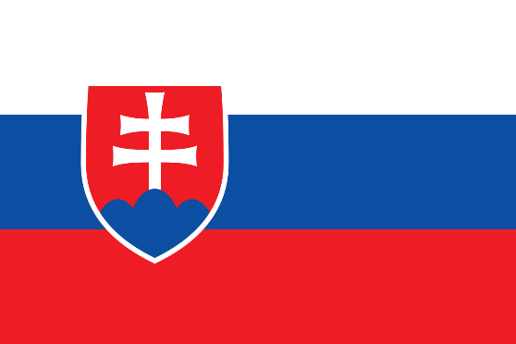 Slovakia

COUNTRY: Slovakia

TOPIC: Collective Defense

COMMİTTEE: North Atlantic Treaty Organization

Within the framework of the analysis of the Slovak Republic , we could say that the country is positioned in an arca that has no steady geographic boundaries. The Slovak Republic located in Central Europe is a relatively small democratic state, with a market economy. This region was quite unstable in the past and it was not easy to delimit its boundaries. Only after World War II was the territory of this region arranged in the form as we know it today. As a part of Czechoslovakia, Slovakia was a member of the Warsaw Pact, which was a rival to NATO, between 1955 and 1991. Slovakia joined NATO on 29 March 2004, along with Bulgaria, Estonia Latvia, Lithuania, Romania and Slovenia, with the 5th expansion, which was the most comprehensive expansion.

The principle of collective defence is at the very heart of NATO’s founding treaty. It remains a unique and enduring principle that binds its members together, committing them to protect each other and setting a spirit of solidarity within the Alliance. The principle of collective defense is enshrined in Article 5 of the North Atlantic Treaty.

To sum of briefly in these two articles, it is mentioned that the members of the North Atlantic Treaty Organization should support each other in the event of an armed attack. And Slovakia helps the members of the North Atlantic Treaty Organization to the best of its ability, and at the same time other countries help Slovakia;

The Slovak government has approved the entry of a 2,100 person contingent of NATO soldiers into the country in order to protect against the increasing Russian threat in 2022. The unit, which was announced to be commanded by Czech soldiers, was said to consist of 700 German, 600 Czech, 400 American, 200 Dutch, 100 Polish and 100 Slovenian soldiers.

And not only with our country, but also with other members of the North Atlantic Treaty Organization provide military assistance to each other;

The United States was the object of brutal terrorist attacks on 11 September 2001. The Alliance's 1999 Strategic Concept had already identified terrorism as one of the risks affecting NATO’s security. The Alliance’s response to 9/11, however, saw NATO engage actively in the fight against terrorism, launch its first operations outside the Euro-Atlantic area and begin a far-reaching transformation of its capabilities. Moreover, it led NATO to invoke Article 5 of the North Atlantic Treaty for the very first time in its history.