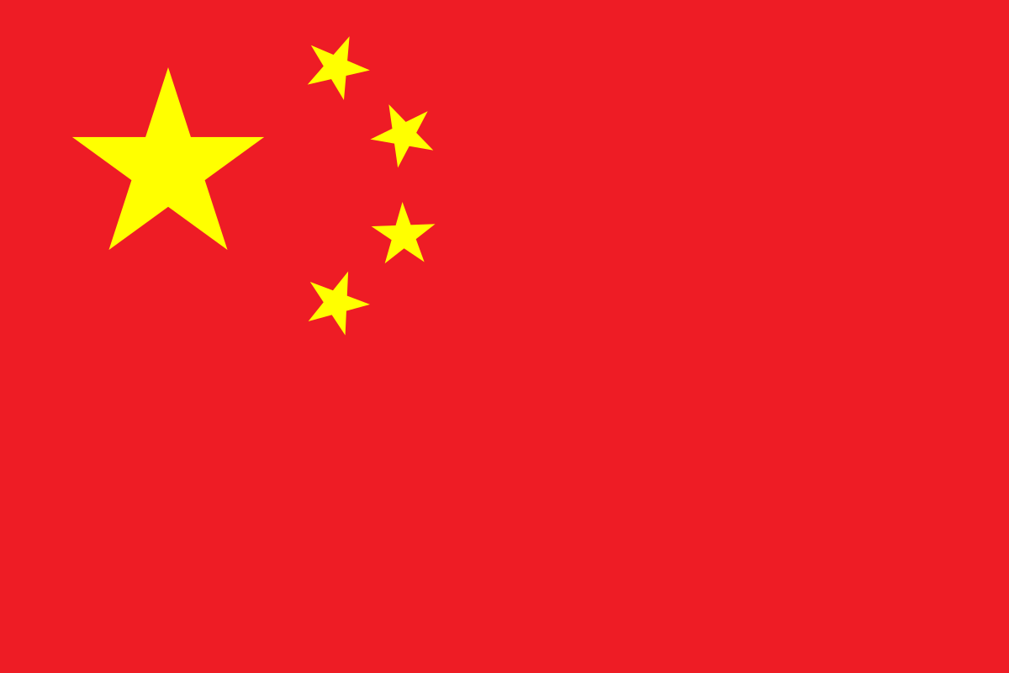**Committee: United Nations Security Council (UNSC)**

**Country: People’s Republic of China**

**Agenda Item: The Situation in the Central African Republic**

Located in Eastern Asia, China borders a total of fourteen countries, including Mongolia, North Korea, Russia, Kazakhstan, Kyrgyzstan, Pakistan, India, Nepal, Afghanistan, and Vietnam, due to being the third-largest country based on land area. China, officially known as the People’s Republic of China is the second-most populated country, and has a population of approximately 1.4 billion. Its capital being Beijing, and covering five different time zones overall, the People’s Republic of China is also one of the five permanent (P5) members of the United Nations Security Council (UNSC).

Prior to the Scramble of Africa, many European states went to discover unknown lands with the intention of discovering new trade routes as a source of improved income, advancements and discoveries regarding scientific research, and seeking development overall. These motives were only supported when the Roman Catholic Church experienced a reduction in power due to the way of scholastic thinking ultimately failing as well as the idea of Mercantilism arising, eventually leading to the Scramble of Africa, seperating it into colonies causing unease both culturally and politically, being taken advantage of for involuntary workforce and the locals constantly being under religious pressure to convert to Christianity. After the formation of the Movement for the Social Evolution of Black Africa (MESAN) party and gaining its independence as the Central African Republic (CAR) in 1960, the former president was overthrown, yet coming back into force after a considerable amount of protests were made by both young students and teenagers unfortunately causing many of them to die, only to be overthrown again. The constant change of power led to the region being extremely unstable, causing apprehension among the locals and exploitation of many civilians as well as violations of human rights. In the aftermath of the significant amount of external pressure, free elections were held, yet were criticized by many due to various issues arising as well as multiple allegations, unpredictably only causing the public's displeasure to accelerate the instability. Subsequent to the Central African Republic Bush War and many agreements of peace being made in regards of the conflict, a rebel coalition named the Selekas took over control, eventually clashing with the Christian anti-balakas, causing civil war, mainly due to the cultural and ethnical reasons as well as the desire to have control over natural sources and power throughoutly. Leading many civilians to be displaced as well as being harmed. Although international help was called, the Selekas refused to disarm, forming ex-Seleka groups until the anti-balakas led to the ethnic cleansing of Muslims over the region. Although presidential elections were held, both Slekeas and anti-balakas were excluded from the new government regardless of the ongoing civil war. Eventually, the United Nations Multidimensional Integrated Stabilization Mission in the Central African Republic (MINUSCA) was formed to bring back stability and peace to the region and also to avoid violations of human rights in the region, experiencing success to some extent yet not having reached the full solution of the problem.

Being strictly opposed to the idea of any possible solution and conclusion thet may interfere with the internal affairs of the Central African Republic (CAR), due to its belief that the government still has the authority and the needed power (rephrase power and needed) to regain control over the current situation on the region, China has publicly announced support for the Central African government especially on the development on matters regarding infrastructure, economy, provision of humanitarian aid, capacity building, moreover the stabilization and regaining control throughly, while calling for cooperation. Moreover, being against of any measures that may include foreign military intervention, possible war crimes, and sanctions on the government of the Central African Republic, People's Republic of China has contrinuted to the efforts of the Central African Republic to restore authority over the situation by multiple ways including the Forum on China-Africa Cooperatin (FOCAC), which supports the Central AFrican government technically and financially by providing trading opportunities that will help improve and stabilize the economy as well as supplying humanitarian and social aid, including the areas of medical assistance, education and infrastructure matters. Moreover, China has openly shown a willingness to remove tariffs on a significant amount of goods from Africa, as a way of supporting them financially. In addition to that China has also supported the peace-keeping forces and its mandate of the United Nations Multidimensional Integrated Stabilization Mission in the Central African Republic (MINUSCA) for permanent peace over the region.

In order to support the government of the Central African Republic regaining control over the situation and for the region to achieve lasting peace, the People's Republic of China would suggest and support solutions that respect the sovereignty of the region within itself and do not involve any external powers interfering with its national matters. For instance, extending and expanding the United Nations Multidimensional Integrated Stabilization Mission in the Central African Republic (MINUSCA) as well as the United Nations (UN) monitored peace-keeping forces currently operating in the region to protect civillians under threat of any form of violence, strengthening cooperation, provision of humanitarian assistance and the monitoring the peace-keeping and peace-building process would be both beneficial both internationally and regionally for the Central African Republic. In additipn to that it could be reccommendedto start fundraising initiatives for the funds raised to be later used asa way to provide humanitarian aids which every human being should have the right to access, including food supplies to avoid malnutrition as well as medical supplies and educational trainings and programs for the civillians in the Central African Republic region as well as an investigation led by ther egional organizations to respect the soverignityand not to interfere with the internal matters of the Central African Republic, such as the African Union (AU) or the Economic Community of Central African States (ECCAS) on displacement to reintegrate the displaced popıulations into safe zones, which may be conducted with the approval of the host country. China also supports a possible peace agreement as well as international cooperation among nations. Finally, the People's Republic of China supports and encourages collaboration and cooperation between international organizations and nations to ensure the permanent peace of the Central African Republic.

Bibliography

<https://en.wikipedia.org/wiki/China>

<https://en.wikipedia.org/wiki/Borders_of_China>

S_RES_2759_(2024)-EN.pdf

<https://en.wikipedia.org/wiki/Central_African_Republic_Civil_War>

<https://en.wikipedia.org/wiki/Forum_on_China%E2%80%93Africa_Cooperation>

<https://www.aa.com.tr/en/africa/china-african-nations-urge-us-to-resolve-trade-tensions-through-equal-talks/3594513>

<https://www.scmp.com/news/china/diplomacy/article/3314143/china-remove-tariffs-nearly-all-goods-africa-both-criticise-us-trade-moves>

<https://www.bastillepost.com/global/article/4332772-china-supports-un-mandates-to-enhance-stability-peace-efforts-in-central-african-republic>

<https://en.wikipedia.org/wiki/African_Union>

<https://en.wikipedia.org/wiki/Economic_Community_of_Central_African_States>