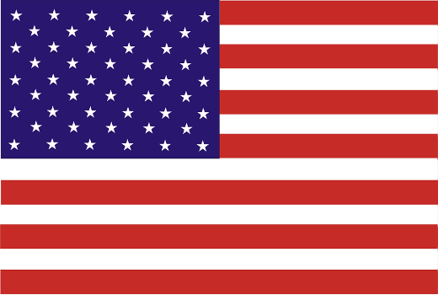**Committee: Special Political and Decolonization Committee (SPECPOL)**

**Country: United States Of America**

**Agenda Item: Government Stabilization After the Bangladesh Political Crisis**

Located in North America, bordering Canada to the north and Mexico to the south, the United States, officially known as the United States of America, is a federal union formed by fifty states and has a population of approximately 340 million people, making it the third-most-populated as well as the third-largest nation in the world.

After gaining its independence, Bangladesh has faced multiple political crises and instability issues, including recent years. Not long after the students studying at major public universities started protesting, requesting the cancellation of the new quota system, mostly due to unemployment issues of those who happen to graduate, as well as corruption and the state of poverty in the economy, the former Prime Minister of Bangladesh resigned from her position. During these protests, many people were left dead and injured, raising concern globally about the violations of human rights in Bangladesh. Furthermore, these crises also led to economic instability and public distrust in the area, in addition to creating many problems in the health sector, making many citizens in need of healthcare services unable to get the treatment they need, as a result of the lack of doctors and healthcare procedures in the region. Consequently, many unauthorized medical assessment centers were established, misdiagnosing numerous citizens and leading to their deaths. Additionally, due to the rising rate of inflation, most importantly in the prices of food and energy sources, cases of starvation have started occurring and the financial capacity of the people has decreased significantly. Even though the state of Bangladesh now has an interim administration, which is supported by many nations, including the United States of America, aiming to stabilize the government both financially and politically, preventing any further cases of violations regarding human rights from occurring and most importantly to keep peace writhing the country, Bangladesh is still facing various amounts of problems, indicating that there is still need for more action to be taken.

Although the United States did not fully express support for the state of Bangladesh in its early days of gaining independence, after the interim administration took authority over the country, The United States of America publicly declared its support for the temporary caretaker government of Bangladesh and its aim to stabilize the government fully after the political crises the state has experienced. Additionally, the United States has supported the stabilization in Bangladesh with the help of organizations, including both the International Rescue Committee (IRC), which provides humanitarian assistance for those who need it in the area as well as employment opportunities, MedGlobal, which provides healthcare services of all kinds as well as medical equipment for the treatments that are needed to be done on patients and to ensure that the public is no longer impacted by the healthcare access challenges caused due to the political crises and the economic instability, also caused by the crises. Moreover, The United States has also expressed its support and hope regarding fair elections, as multiple elections in the past have been criticized for being unfair and irregular, minimalization and prevention of corruption, and avoiding the violations of human rights with the assistance of the new interim administration, while also achieving their goal of stabilizing the government of Bangladesh.

In order to support the government of Bangladesh being stabilized after the political crisis, the United States of America recommends that nations assign voluntary medical health professionals with enough experience, who meet the standards required for healthcare workers in the state of Bangladesh, to work and operate in Bangladesh, with the intention of minimalizing the effects of the hardships accessing healthcare. With a similar purpose, the United States encourages more nations to endorse and contribute to the efforts and actions of both UN bodies, including the United Nations Development Programme (UNDP), which works to improve the financial and sustainable development in the state of Bangladesh, and non-governmental organizations (NGOs) such as ActionAid, which serves a similar aim to the United States Agency for International Development (USAID), operating in order to ensure the prevention of human rights as well as the adjustment to climate change, as the location of Bangladesh causes it to encounter many climatic challenges, by funding and monitoring their projects and actions. Additionally, with the usage of media and digital platforms updating and informing the international community about the ongoing situation in Bangladesh, without delivering inaccurate information is possible. In addition to that, the usage of these sites also creates space for strategy development in case of a similar event occurring in the future, raising awareness in the global community, promoting transparency as well as accountability, and most importantly rebuilding public trust. Finally, the United States supports and encourages collaboration and cooperation between international organizations and nations to ensure the stabilization of the government of Bangladesh.

Bibliography

<https://en.wikipedia.org/wiki/United_States>

<https://en.m.wikipedia.org/wiki/2024_Bangladesh_constitutional_crisis>

<https://www.rescue.org/eu/country/bangladesh>

<https://medglobal.org/bangladesh/>

<https://bdnews24.com/bangladesh/70be1b90a6a0>

<https://www.actionaid.org.uk/about-us/>