Egypt  UN Women Comittee  Women Rights in Afghanistan  Egypt has been ruled by patriarchy since ancient times. Therefor women in Egypt do not have rights as many as men’s. In Egypt women have some responsibilities for their family and country. These responsibilities are getting married, starting a family and having kids. | 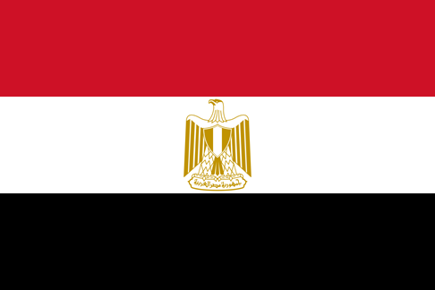
Egypt cares men’s education more than women’s and pays more attention to men’s health. Egyptian men have more access to assets than Egyptian women, also Egyptian men have more voice than Egyptian women in public and as you see a lot of CEOs in Egypt are men. Women and girls in Egypt exposure to violence and sometimes they are subjected to murder.
As the delegate of Egypt we are supporting Afghanistan and we will continue to support Afghanistan. Because we believe that men are stronger than women, they are more intellegent, better at sports, they run the business better… So we think men are better than women in every single thing and men deserve so much more than women. Also Egypt and Afghanistan are Muslim countries and Muslims rule their live with Quran. Quran is the book that Muslims must obey to it. According to Quran men deserve more than women.
As a solution to women’s rights in Afghanistan, Egypt suggests easing the policies against women but we support Afghanistan for this issue so we won’t suggest so many solutions for this issue.
Ada Gazel-Delegate of Egypt

