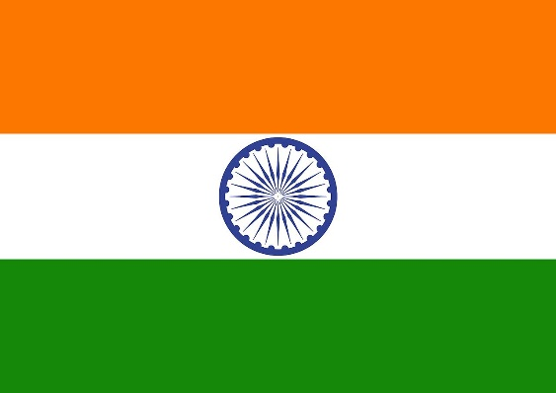Country: India

Committee: UN WOMEN

Position : Delegate

Topic:Protecting the Rights of Women in Afghanistan

We, India, strongly oppose the injustice, oppression and devaluation of women in Taliban-ruled Afghanistan. before we present our thoughts and solutions on this issue, we would like to address a problem. Unfortunately, our own country is not very welcoming when it comes to "the value given to women." although we are uncomfortable with this situation, it is a reality: We are one of the countries with the highest number of sexual assaults against women and children. The low female population in our country also leads to an increase in sexual crimes. That is why we have taken a number of measures to defend women's rights, including legislative reforms, awareness campaigns and support services. We have strengthened laws to address issues such as sexual harassment and domestic violence. It would be absurd for us to discuss women's rights without mentioning the difficulties that women face in our own country, even if not as much as in Afghanistan.

India is undoubtedly one of the countries most concerned about the withdrawal of US troops from Afghanistan. In fact, our discomfort with the Taliban takeover of Afghanistan is not new. When the Taliban and the US signed an agreement in Doha, Qatar, in February 2020 for the withdrawal of US forces by the end of 2021, many of our experts said that Afghanistan would be left at the mercy of the Taliban and Pakistan. After the Taliban took control of Afghanistan, we, unlike Russia and Chiana closed our embassy in Kabul,. We do not support the Taliban's suppression of women's rights and freedoms under the guise of so-called religious scripture. We do not support it and we condemn it. Just as we do not remain silent in the face of violence and injustice against women in our own country, we are here in Afghanistan to offer all the opportunities and solutions we can to ensure that women are given the value and respect they deserve, and we stand behind them.

India is committed to a policy of development projects, including education and healthcare, aimed at empowering Afghan women.

\*In addition, diplomatic efforts and partnerships with international organizations are part of our approach to address the challenges faced by Afghan women.

\*Apart from this, another solution that we can offer to you, distinguished delegates and chairpersons, is to help the women of Afghanistan to resist. We know that no matter what they do, they are always oppressed by force, but we do not believe that these restrictions can be ended without resistance and war.

\* We should not turn our backs on them in this difficult time, and we should help them. This is not only a matter of conscience, but also a matter of humanity.