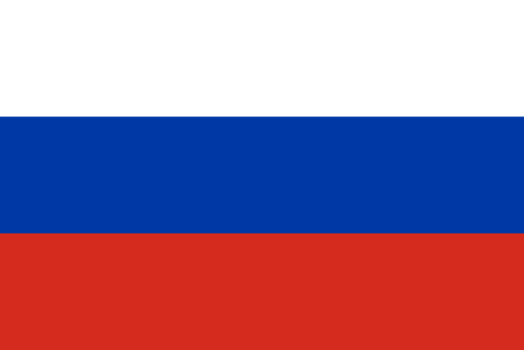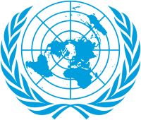**Committee:** *Special Political and Decolonization Committee (SPECPOL)*

**Topic(s) / Agenda Item:** *Israeli-Palestinian Conflict, The Military Occupation of the Gaza Strip and Its Implications*

**Country**: *Russian Federation*

**Delegate**: *Yuksel Emre Irmak*

We, As Russia, have been engaged in many armed conflicts to protect our sovereignty and security throughout our history. We are fully aware of the importance of armed conflict in national defence and we have supported those who fought for their independence or against agents of terror in the past. However, Russia cannot expand this support to those who commit crimes against humanity under any circumstances. The Russian Federation urges the conflict between Palestine and Israel to end before it can claim more lives.

The conflict between Palestinians and Israelis has been raging since the beginning of the 19th century as Palestine broke away from the Ottoman Empire and was subsequently mandated by the British Empire. Although Russia believes that the UN Resolution 181(II) was an adequate attempt to bring a peaceful end,the resolution has resulted in a conflict between the Arab League and Israel in 1948. The subsequent wars that occurred in Palestine resulted in Israel occupying large parts of Palestine (Those wars being the Yom Kippur and the 6-day wars) and have led to resolutions 242 and 338 being passed by the UNSC. The General Assembly reaffirmed the rights of the Palestinian people and gave the Palestinian Liberation Organization (PLO) the Observer entity status. After the Invasion of Lebanon by Israel to expel PLO occurred in 1982, the UN established the International Committee on the Question of Palestine (ICQP). A massive revolt against the Israeli occupation happened in 1987 dubbed the Intifada. In 1991 a peace conference in Madrid was held. Negotiations between the Palestinian and Israeli states led to the Declaration of Principles on Interim Self-Governance Arrangements (DOP or Oslo Accord). In 2002 UNSC affirmed a two-state vision. In 2003 the Quartet (US, EU, UN, Russia) released a roadmap leading to a two-state solution. Following the 2007 takeover of Gaza by Hamas, easing tensions between the two countries have reignited. In late 2008, Israel conducted the operation “Cast Lead” which led to the UNSC adopting Resolution 1860. Violations of international law were investigated by the UN. Several negotiations broke down between 2010 and 2016. In 2016, UN adopted the resolution 2334. In 2023 another round of hostilities broke between Israel and Hamas on May 15th and a full-scale conflict in October of 2023 (UN, 2023)

As the historical evidence points out, both the former Soviet administration and the current Russian administration have shown support for maintaining peace and establishing just borders in the Palestinian area. The Russian Federation also fears that this local conflict will spark a new regional crisis in the Middle East and cause more devastation than it already has. (Al Jazeera, 2023). The Russian Federation also is extremely concerned with the violence occurring in Palestine and calls to return to peace. (Reuters, 2023)

To ensure lasting peace and protection of the rights of both nations involved, the Russian Federation proposes to enable negotiations for both nations to enact Resolution 2334 passed in January 2016 and the resolutions passed before, encouraging a ceasefire between the two states to de-escalate the conflict, establishing an international committee to coordinate humanitarian efforts both in Palestine and Israel, supporting the creation of “safe zones” under the control of non-profit relief organizations (such as the Red Cross and the Red Crescent) that provide immediate medical aid and shelter for the injured civilians, independent of any connections to both parties.

The Russian Federation believes that the establishment of NPO “safe zones” will deter any side from attacking medical institutions under the cause of being used by the enemy forces. The Russian Federation also believes that both Israel and Palestine deserve to have their states run by their people and endorses the two-state solution resolution 2334 and the resolutions before suggested. The Russian Federation sincerely believes that the member states of SPECPOL will reach an agreement that promotes peace and prosperity for both Palestine and Israel.

REFERENCES

United Nations. (2023). *History of the question of palestine - question of Palestine*. United Nations. https://www.un.org/unispal/history/

Al Jazeera. (2023, October 19). *Russia’s Lavrov warns of regional spillover from Gaza crisis*. https://www.aljazeera.com/news/2023/10/19/russias-lavrov-warns-israel-gaza-war-could-spark-regional-crisis

Faulconbridge, G. (2023, October 9). *Russia accuses us of “destructive” approach on Israeli–palestinian war*. Reuters. https://www.reuters.com/world/kremlin-warns-there-is-risk-regional-escalation-after-israel-violence-2023-10-09/