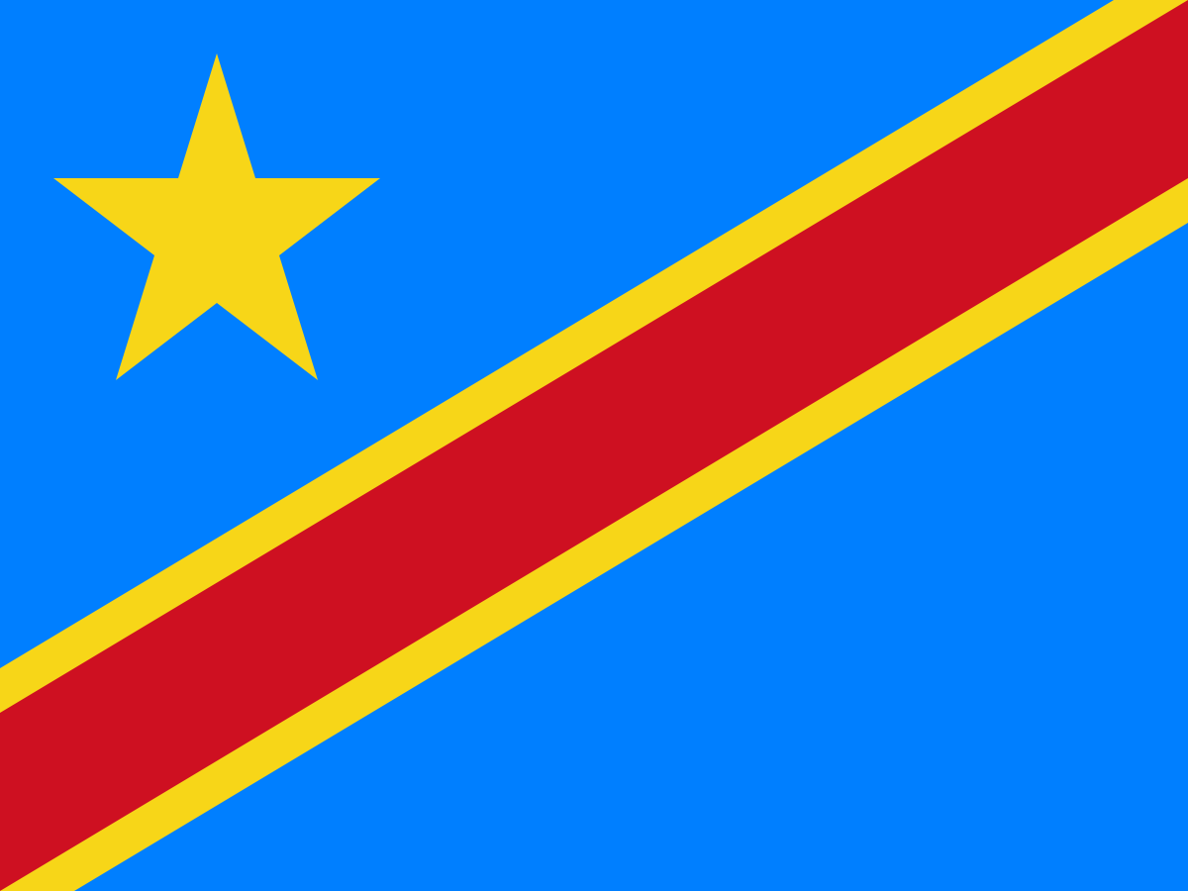

Committee: United Nations Children's Fund (UNICEF)

Topic: Assessing the Current Situation of Child Labor

Delegation:Democratic Republic Of Congo

Delegate:Yiğit Tangül

Democratic Republic Of Congo is a country in Central Africa which is rich about oil reservoir and underground sources sucs as diamond,copper,gold etc. . Democratic Republic Of Congo is one of the richest countries about underground sources and oil reservoir in the world. The economy is based on natural resources. The population is 111,859,928 in 2023. There are people from different religions and ethnic groups in the country. French is the official language of the country. The education expenditures rate is 2.7% of GDP. Literacy rate is 77%.

Child Labor is one of the most important problems in our world. Unfortunately, some childs are forced to labor in the world and the number of these childs are very high. Childs are in a huge danger by these hazardous works. These childs can have physically and mentally big diseases and they can pass away because of the forced labor. We have examples about these possiblities from our world. In Democratic Republic Of Congo, the age structure rate of 0-14 years is 45.99%. And the total fertility rate is 5.56 children born/woman. These percentages are high because of the cultural preference for larger families. The 17.4% of 5-14 years are working. 16.3% of 7-14 years are combining school and work. Most of the child are forced to mining. The government is taking steps to decrease these rates. In 2022 the government started the Inter‐ministerial Commission to Combat Child Labor in Mines and Artisanal Mining Sites launched the Child Labor Monitoring System. While trying to decrease these rates the government is also taking steps about education system.Democratic Republic of Congo made a noticeable affect about the primary education over the past years but unfortunately there are still some childs working and not getting education. As the government needs financial resources for this investments on education, the country produces underground sources to other countries and invigorate the economy.

To eliminate child labor we can start by checking the countries policies about child labor. By checking these policies we should regulate these policies to a correct form which can be recommended by UNICEF to the countries. Also with these regulations countries should collect and publish their datas about the child labour. These datas should be analysed by autonomous organizations. These autonomous organizations should give informations,suggestions to the countries.Governments and agencies should be coordinated. Countries can get coordinated as well as governments and agencies And with these coordinations, countries can take detailed suggestions from these agencies. Countries should invest and budget for education more because the childs which don’t take education can face child labour. Countries should improve their security and inspection systems about childs.