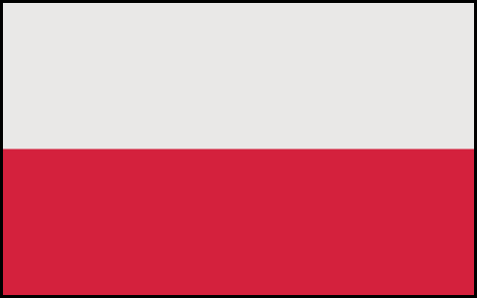
Commitee: The United Nations Development Programme
Agenda: Production of Sustainable Biomass Energy
Country: Poland

Biomass energy is renewable organic material that comes from plants and animals for instance wood, forest residues or plant materials. Biomass has been used as a source of energy for as long as humans have been creating fire and Poland believes that using biomass energy more efficiently with the help of other countries would achieve a cleaner world.
In 2017, bioenergy in Poland accounted for 82 % of all RES and has been following a program about using renewable and biomass energy sources.Currently the share of biomass in the total potential of renewable energy sources is 50%, and it is expected to rise to 70% in 2050. Our government has been supporting prosumers which are consumers who are producing their electricity from sustainable energy sources. With a biomass potential of 895 PJ, Poland has one of the highest biomass potentials in the EU and has almost 14 million hectares of arable land, giving the country a very high biomass supply. Additionally, there are many EU and international funds available to help Poland with increasing our sustainable energy sources.
We believe Poland could encourage small projects that are trying to produce biomass energy and try to provide them with incentive pay as well as build biomass power plants on arable lands. We could suggest using the co-firing method because co-firing would increase the efficiency of biomass energy production and result in a lower carbon footprint.

References:
Energies | Free Full-Text | Energy Use of Woody Biomass in Poland: Its Resources and Harvesting Form (mdpi.com)
What is biomass? - Drax Global
From coal to biomass? Bioenergy in Poland – BalticBiomass4Value Cofiring Biomass - an overview | ScienceDirect Topics
https://www.agroberichtenbuitenland.nl/binaries/agroberichtenbuitenland/documenten/publicaties/2020/02/27/factsheet-bioenergy-poland/Factsheet+bioenergy+Poland+Feb+2020.pdf

