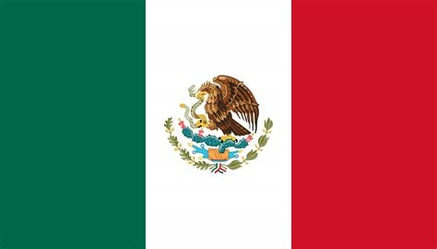

**Committee :** United Nations Children’s Fund (UNICEF)

**Country**  **:** Mexico

**Agenda Item :** Assessing the Current Situation of Childish Labor

Mexico is officially the United Mexican States country in the southern part of North America. Mexico’s north side adjoins with United States, South and West sides are bordered by Pasific Ocean, Southeast part is framed by Guatemala, Belize and the Carribean Sea, east by the Gulf of Mexico. It covers 1.972.550 (one billion nine hundred seventy five million five hundred fifty) km2 and this makes us 13th largest country of the world by area. Almost 130 million people lives in Mexico and this crowd allows to became to 10th most populous country in the world. Mexico accomodates to most Spanish speakers in the world. Mexico governed by federal republic and it comprises 31 states and the capital is Mexico City.

The United Nations Children’s Fund formerly known as United Nations International Children’s Emergency Fund was constituted on December 11, 1946 by the United Nations General Assembly to provide emergency food and healthcare to children and mothers in countries sacked by World War 2. Since the beginning of our foundation our current aim is always defending the children right, assigning in adressing their most basic needs, increasing and equalizing changes for every kid who lives another country from each other. Child labor is one of our primary concern. In our committee we will mainly focus on children rights who are exposed to child labor. In last years child labor is increasing and current situation is showing us in totally 152 million of child workers are living with us according to fields of International Labor Organization.

Around the world these young workers do not only working labour as agriculture, domestic work or something else looks simple. They are in every industry as illegal and hazardous jobs like commercial sexual exploitation, drug trafficing, stealing fuel, carrying out armed attacks, including the production of poppies for heroin and extra. When this childrens grows up their life can be damaged and we do not support theese jobs and we think childrens have to be protected by us. If we are here for our worlds children, we must put in order their lifes.

As Mexico; we have laws for commute the child labors occupations. When they have no choice for continuening their lifes we have to help them as their government. For instance; The Department of The Labor is responsible for protecting workers rights, including monitoring child labors. In Mexican laws; the children workers who is under 16 are not allowed to work more than six hours per day. Fortunately the child labor in Mexico has been slowly decreases under favour of proggrammes like ‘Oportunidades’. This programme is mostly focus on decreasing the child labor in Mexico by providing families with educational grats. With these grants more children will be able to stay in school instead of working. This programme helps so many families and children more than four million.

As Mexico ; we believe that we should mainly focus on our children’s education . We believe that UNICEF should share the responsibility of edutacing the families so that we can reintroduce the children to society. When theese children grow up, they will both educated and business experienced. But our primary aim is always protect our children from child labor, if we can not avert this situation we should lay claim to them.