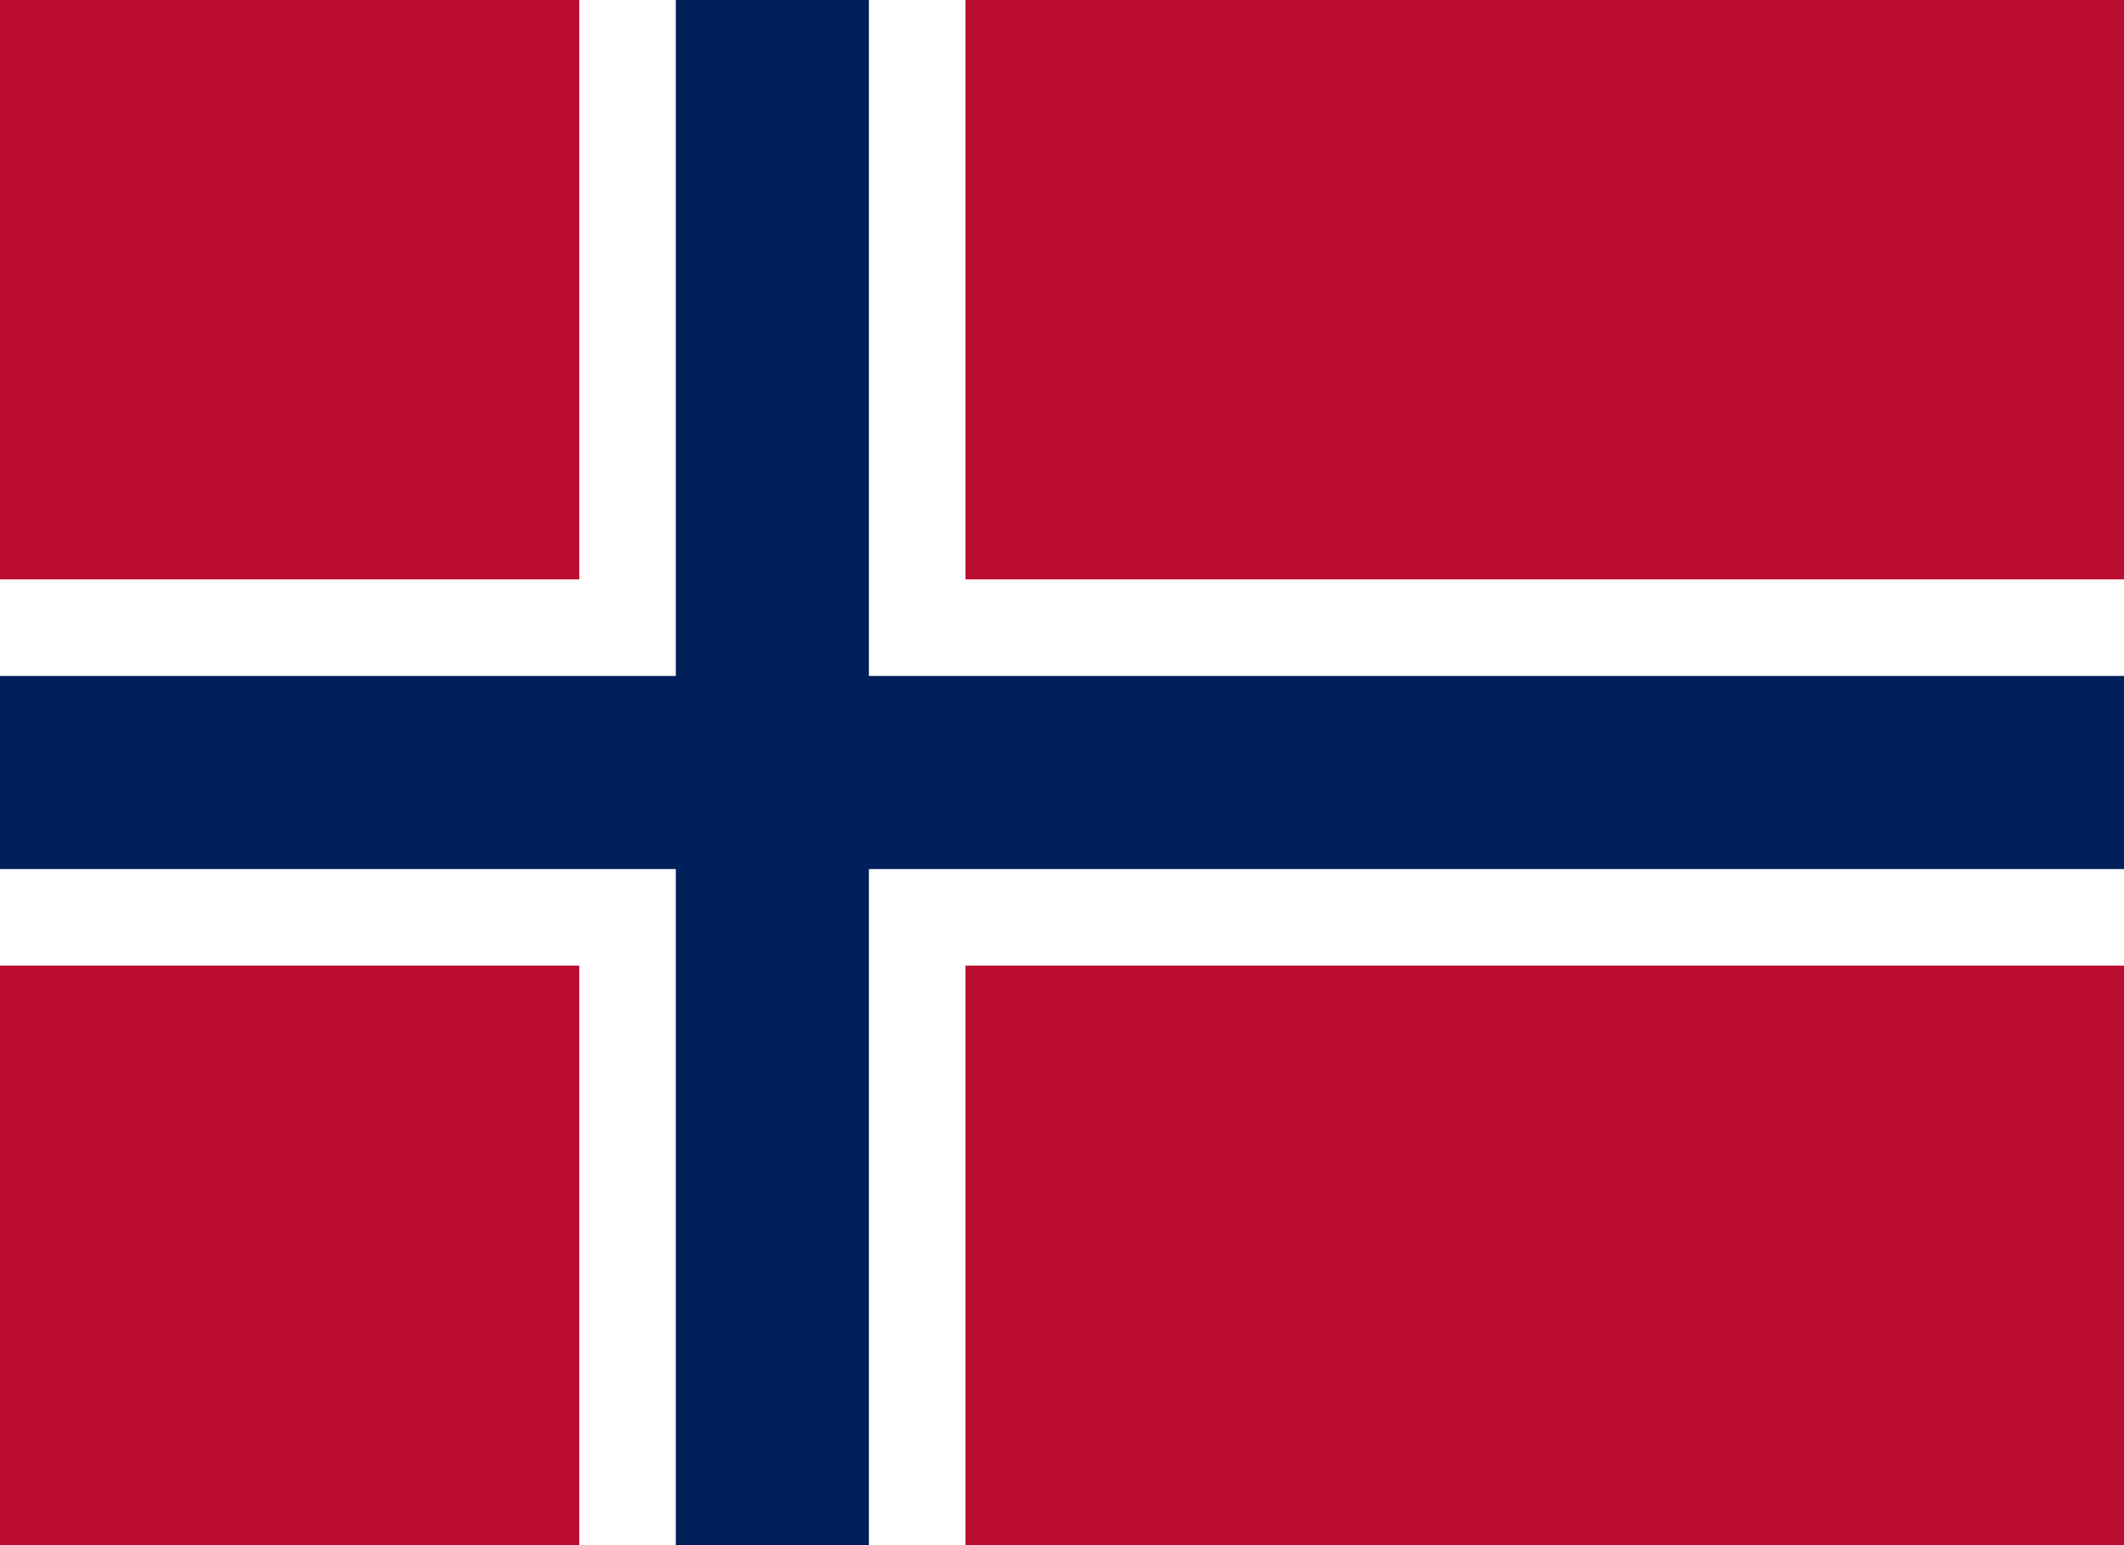Committee: United Nations Children’s Fund (UNICEF)

Country: Norway

Agenda Item: Assesing The Current Situation of Child Labor

Norway is located in the north of Europe, on the Scandinavian peninsula. The official language of Norway is Norwegian. The capital city of Norway is Oslo.

The United Nations Children's Fund (UNICEF), was established in 1946 to help mothers and children who were harmed in the World War II, by the United Nations General Asembly. UNICEF was founded to defend children's rights. UNICEF is aims to protecting the children who in the difficult situations. UNICEF works to protect children’s rights.

If other members of society benefit as well from child labor, it will cause child labor to spred all over the world. Child labor is common in sectors such as agriculture, domestic work, mining and quarrying.

The United Nations has signed the “Minimum Working Age Convention” and “Children’s Rights Convention” against child labor. UNICEF has developed varius projects to increase children's access to education, provide support the families and protect the children. UNICEF has worked to reduce child labor, especially in the areas of education and social protection.

Norway has strict laws forbidding child labor. In Norway, children under the age of 15 are prohibited from working and their education is given importance. Norway organizes social services that help families raise their children in healthy conditions. Norway works to prevent child labor in coperation with international organizations and other countries.

To prevent child labor; acces to education should be facilitated, families with children should be supported and their incomes should be increased, laws to prevent child labor should be strengthened. Also poverty should be reduced and Countries should come together and international cooperations should be established against child labor.