
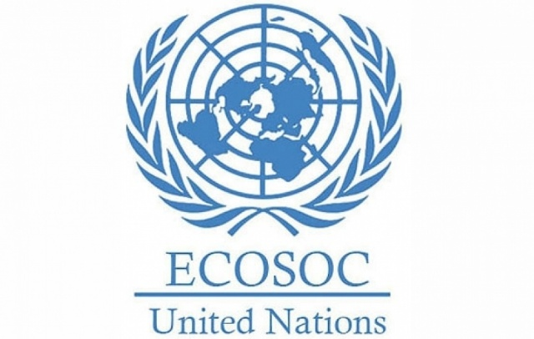

Delegate:Aybars Yavuz
Topic:Tackling Youth Unemployment and
Promoting Sustainable Economic Growth
Delegation:The Rebulic Of Philippines
Economic and Social Council(ECOSOC)

The Republic of the Philippines recognises that youth unemployment is one of the most critical global challenges with direct links to sustainable development. With over a third of its population under the age of 30, the country is faced with the pressing issue of providing decent jobs and opportunities for all. The government recognises that young people are key drivers of innovation, productivity and inclusive growth.

Recently, the Philippines has introduced programmes such as JobStart Philippines, the Youth Entrepreneurship Programme and TESDA skills training, in order to equip young citizens with the skills they need to enter the labour market smoothly. However, issues such as skill mismatch, informal work and lack of access to technology impede progress. The Philippines supports initiatives that promote digital literacy, green jobs and sustainable entrepreneurship to prepare young people for future economies.

One way to address this global challenge is through international cooperation. The Philippines is cooperating with the ILO, UNDP and ASEAN to advance equal opportunities in education and employment for all. The nation also encourages private sector participation as a means of generating innovative and sustainable jobs.

The Philippines firmly believes that empowering young people through quality education, sustainable job creation and global cooperation will lead to inclusive and resilient economic growth for all.
Referances: https://www.eeas.europa.eu/eeas/eu-and-philippines-enhance-security-cooperation_en
https://www.undp.org/sites/g/files/zskgke326/files/2025-02/2025-asia-pacific-sdg-partnership-report.pdf
https://www.adb.org/news/features/giving-hope-young-filipinos-through-jobstart-philippines

