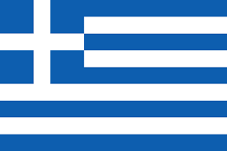

**Country:** Greece

**Committee:** UNICEF

**Topic:** Assesing the Current Situation of Child Labor

Greece is country in southesat Europe. Although Greece has a deep-rooted history, Greece was founded in 1830.The largest city and capital of the country, whose population is approximately 10.3 million as of 2022,is Athens.

Greece,supports the struggle about the assessment of the current situation of child labor. The Greece Republic purposes to children can thrive in environments that are free from exploitation and to their well-being.

Almost every country has prevalance of child labor .160 million children are child labor in the world and the 58% of them is boy %42 of them is girl. At the same time, Child protection problem is very big in our. As a result, Greece has made significant progress about Assesing the Current Situtation of Child Labor. This includes comprehensive legislation, accessible education, andial programs. Greece approved ILO Convention No. 182 on the Worst Forms of Child Labor.

Greece has initiated many national efforts, such as passing the law on the employment of minors. To explain It has been adapted to the provisions of the 138th international labor convention, which allows the employment of minors in accordance with the existing Greek legislation and the performance of light work for children over 14 years of age. A Presidential Decree concerning 18-year-old children was prepared in order to determine the working conditions of minors. Accordingly, it is defined as a young child who has not reached the age of 15 or is still subject to compulsory education.

Greece is determined secure children by doing many more studies like the ones it has done.