Country: Algeria

Committee:DISEC

Agenda Item: Improvement of Peacekeeping Missions in the Sudanese Region

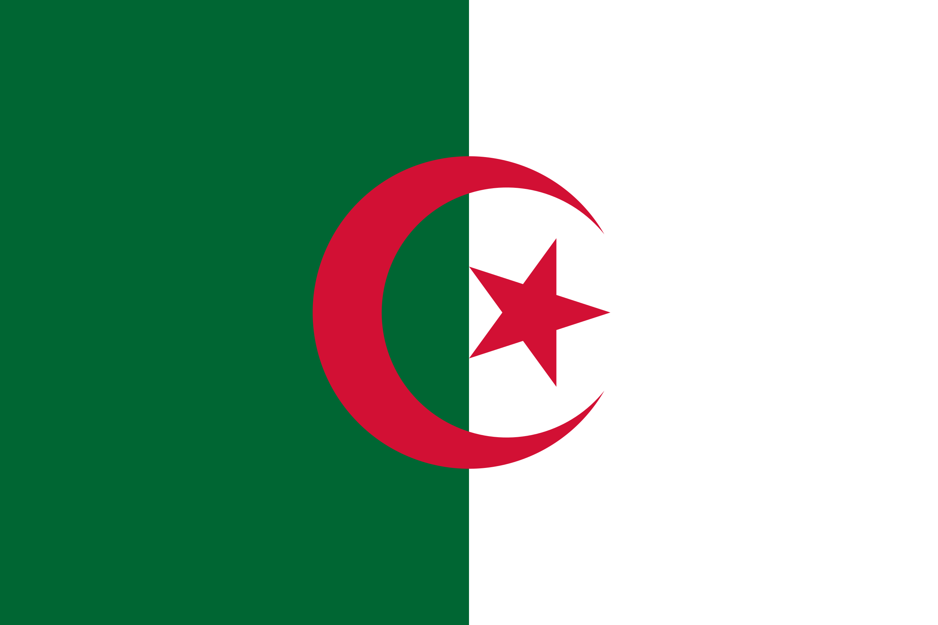

The People’s Democratic Republic of Algeria is a country in Africa with an estimated population of 44 million people and covers an area of 2,381,741 square kilometers, making it the largest nation in Africa. Algeria has a semi-arid geography, with most of the population in the fertile north. The capital and largest city is Algiers, located far north of Algeria; it is a coastal city with a population of 2,854,000. The currency of Algeria is the Algerian dinar. Official languages are Arabic and Berber.

Algeria has been conducting neutral policies in times of conflict between nations. Algeria is committed to bringing peace and stability to Africa. Algeria has a deep understanding of the conflict in Sudan. It has been involved in diplomatic efforts to resolve conflicts in Sudan, such as the Darfur conflict, with its support to South Sudan and the South Sudanese War of Independence. It has supported peace and made mediation efforts in collaboration with the African Union and the Arab League.

As the delegation of Algeria, we know how hard it is to restore peace. Sudan and South Sudan have had a very unstable government since its independence with many military coups. Its international relations with other countries made it hard to find common ground. We support that the government should keep its promise of the powersharing agreement of 2019. The agreement stated that both civilians and the military would control the country. The military for 21 months and civilians for 18 months. We support that the transitional council should be made as we did in 2019. The people of Sudan are tired of fighting a war they tried to avoid. By cooperating, we can enforce everlasting peace for a better future.