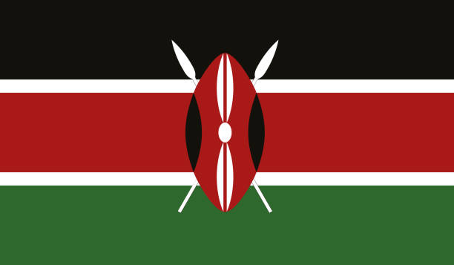Conference: TEDUTRAIN’23

Committee: CND

Topic: Cooperation to combat with Narco-Terrorism and Drug Trafficking

Delegate: Hamza Efe Ekici

### The Republic of Kenya is an African country which is located in East Africa. Kenya’s population is 55.549.185. It is the 26th country with the most population in the world. Also it has a population density of 97 people per km².It is neighbors with Tanzania in South, Uganda in West, Somalia in East and South Sudan with Ethiopia in North. It has a land mass of 582.961 km² and it’s the 48th biggest country in the world. The capital city of Kenya is Nairobi and it’s the most crowded city in Kenya.The currency of Kenya is Kenyan shilling. 1 Kenyan Shilling equals 0.0065 USD. Kisumu, Thika, Mombasa and Nakuru is some of the major cities in Kenya.

**Narco-terrorism and drug trafficking harm international security and countries’ economy. Also it affects human relationships negatively and causes crimes and destroys the social secure environment.**

**Drug trafficking is an unacceptable crime. Hence, the UN should increase the security and expand the drug audit ranges all around the world. Otherwise, this problem will get bigger and one day, there will be nothing we can do.**

**As the Republic of Kenya, we are increasing the precautions and trying to keep kids away from this bad business. We are also trying to raise awareness especially in cities where drug trafficking is so common. We created a portable school to keep the teenagers out of this dangerous business and we are trying to pay their attention to school to beat addiction and reduce the amount of drug trafficking.**

**According to the Kenyan law’s 4th article,**

**-If a citizen is carrying 1-100 grams of drugs, the punishment of it is going to be 30 million shillings and imprisonment.**

**-If a citizen is carrying more than 100 grams of drugs, the punishment is going to be 50 million shillings or three times of the market value of the substances with imprisonment.**

**We defend that the United Nations countries must collaborate in this situation and should solve this global problem permanently. Because people are endangering their lives and getting bad habits. We hope that everyone on the planet can beat their drug and narcotic substance addictions and escape from this dirty trade sector.**

**Sources:** [**https://tr.wikipedia.org/wiki/Kenya**](https://tr.wikipedia.org/wiki/Kenya)

[**http://kenyalaw.org/**](http://kenyalaw.org/)