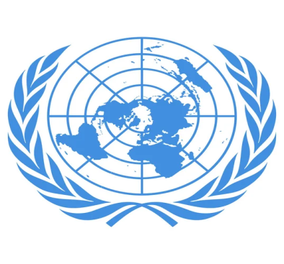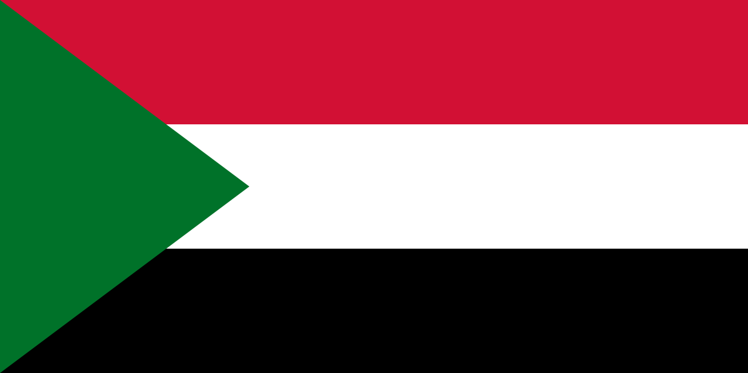 Curbing Human Trafficking, Child Labor and

Terroism in Culturel Properties

Committe: Sochum

Country: Sudan

Delegation: Zeynep KILIÇ

We are the third largest country in Africa, loceted in North East Africa. We have a population of around 46 million. Although we have rich resources and vast territories, we face economic and social difficulties due to civil wars and political instability. At the same time, we struggle with issues such as human trafficking, child labour and terrorism.

In the past, we have been one of the importent centers in these issues due to our strategic position as well as historical and socio-political factors. Especially in human trafficking, women and children have been targeted in our country. Child labour and terrorism have also become common in our rural areas. In the 1990s and early 2000s, civil wars and economic difficulties increased due due the influence of terrorist groups and radical Islamist communities, which actually led many children in our country to enter the working life in order contribute to their families. These children were used in many hard labour jobs. For example, in mining or agriculture, where they had to do a lot of hard labour.

As Sudan, we aim to take importent steps on issues such as human trafficking, terrorism and child labour. However, in order to end these problems in our internal conflicts. Internal disturbances in our country both threaten security and damage national unity and solidarity. Acting in unity and solidarity is an important step to solve these problems. Therefore, when the internal turmoil ends, it will be possible to make more accurate and sound decisions in an enviroment of peace and security.

After that, we belive that our country should be a secular country as well as Muslim country because secularism is an importent element to root out radical Islamist and terrorist groups. We must take similar steps by drawing on the experience of all secular states and with their help, following their example. If we can eliminate religious and politacal divisions, we will be able to create a structure that embraces all sections of our country.

And last but not least, once we have secularand peaceful conditions, we must pay great attention to the educiton system. Education is a critacal point in these issues because the children of a country are the future of the country. After rebuilding schools destroyed or ruined by the war and improving the quality of the education system, children should be instilled with a love for their homeland and become responsible members of their society. In addition, children need to be encouraged to go to school, so various educational materials should be provided. Let us not forget that these issues concern not only us but the whole world. Therefore, it would be more peaceful and logical to overcome these problems with global co-operation. In these process, we request assistance from countries with economic means and action should be taken to provide educational materials and infrastructure support. Every human being has the right to life and states should not hesitate to take resbonsibility for ensuring this right.

BİBLİOGRAPHY:

<https://tr.wikipedia.org/wiki/Sudan>

<https://www.insamer.com/tr/ulke-profili-sudan/>