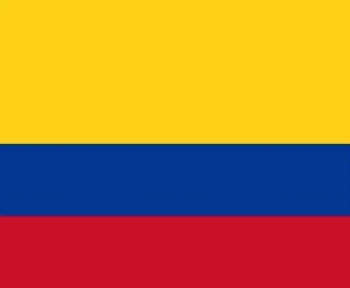 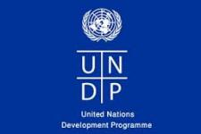  
 **Committe:** UNDP  
 **Agenta:** Production of Sustainable Biomass Energy  
 **Country:** Colombia  
  
Colombia,is a country mostly in South America with insular regions in North America.The Colombian mainland is bordered by the Caribban Sea to he southeast,Ecuador and Peru to the South and southwest,the Pacific Ocean to the West and Panama to the northwest.Colombia is divided into 32 departments.The Capital District of Bogota is also the country’s largest city hosting the main financial and cultural hub.Other major urbes include Medellin,Cali,Barranquilla,Cartagena,Santa Marta,Cucuta,Ibague,Villavicencio and Bucaramanga.It covers an area of 1,141,748 square kilometers,and has a population of around 52 million.  
  
  
Colombia perspectives on biomass energy vary.Some appreciate its potential as a renewable energy source,considering the country’s rich biodiversity.However,concerns about deforestation and land-use changes for biomass production have sparked debates about its environmental impact.Balancing energy needs with sustainable practise is a key consideration in discussions about biomass in Colombia.The country has abundant agricultural residues and organic waste,providing potential for biomass utilization.However,considerations about environmental impact,land use and the effiency of biomass Technologies are essential in shaping Colombia’s approach to incorporating biomass into its energy mix.  
  
**Source:  
-Wikipedia  
-www.GOV.CO**