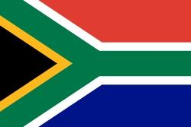**Committe:** Specpol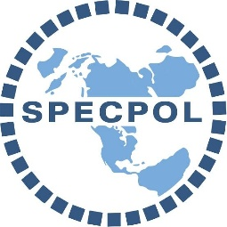

**Delegate:** South Africa

**Agenta:** Israeli- Palestinian Conflict- Military occupation of the Gaza strip and its consequences.

**South Africa,** officially the public of South Africa is the southern most country in Africa. Around the country in Africa. Around the country neighboring; Namibia, Botswana, Zimbabwe, Mozambique. The main languages We speak or Africans and English. most of our people are in the religion of Christianity. A really small part of communitier Is in the Islam religion.

In the recent month a fight between Gaza and Israel this fight is proven to be deathly for the people of Gaza end we as a country can't stand this meaningless genocide anymore.

The Israeli- Palestinian Conflict Is the is the ongoing armed conflict between Palestine end the Israel armed forces In Palestine territory. Due to the economic threats off oil rich countries in the Arab world, most African countries ended their relations with Israel. South Africa made the following statement about this incident; “A genocide is taking place in Gaza,which has turred into a concentration camp today. ,As South Africa, we have very clearly express it or attitude towards the operation carried out especially against hospital.”

It was also recently proposed to suspend diplomatic relations with Israel and close the Israeli embessy in preterio by a parliamentary decision. South Africa has long been advocate for peace in the region, likening the plight Off Palestinians two its own under the a apartheid regime that Ended in 1994. And we propose A diplomatic agreement.

**I would like to point out some of the sites Where I got help with my research;**

<https://tr.m.wikipedia.org/wiki/%C4%B0srail-Filistin_%C3%A7at%C4%B1%C5%9Fmas%C4%B1>

<https://www.bbc.com/turkce/articles/crg3gv17p00o.amp>

<https://apnews.com/article/south-africa-israel-ambassador-recall-gaza-bb30d780d0d33f2220dc08bf032a5738>

<https://en.m.wikipedia.org/wiki/South_Africa>