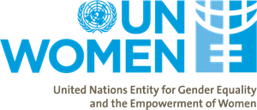
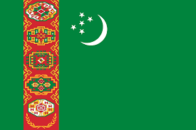

Country: Turkmenistan
Committee: UNWomen
Agenda Item: Protecting the Rights of Women in Afghanistan

The delegation of Turkmenistan acknowledges the critical importance of addressing women's rights, especially in the context of Afghanistan. As a nation committed to the principles of equality, justice, and human dignity, Turkmenistan recognizes the need for comprehensive and sustainable solutions to promote and protect the rights of women in Afghanistan.

Turkmenistan understands the historical challenges faced by the women of Afghanistan. decades of conflict, and cultural shifts have left women badly affected, limiting their access to education, healthcare, and economic opportunities. Recognizing the unique challenges faced by Afghan women is essential in formulating effective policies to improve their situation.

Turkmenistan notes with concern the current status of women's rights in Afghanistan. While progress has been made in recent years, significant barriers persist. Issues such as gender-based violence, limited access to education, and restricted participation in political processes remain critical challenges. Turkmenistan urge the international community to collaborate and support Afghanistan in addressing these issues comprehensively.

In conclusion, Turkmenistan stands committed to working collaboratively with the international community to address the pressing issue of women's rights in Afghanistan. By implementing comprehensive and sustainable strategies, we can contribute to creating an environment where Afghan women can fully enjoy their rights and actively participate in the development of their nation. Turkmenistan thinks that, through collective efforts, we can make meaningful progress in promoting gender equality and women's empowerment in Afghanistan.
Thank you.

