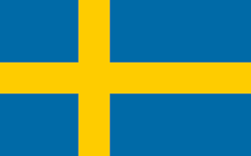Country: Sweden

Committee: SOCHUM (Social, Humanitarian and Cultural Committee)

Agenda Item: 1. Taking Action In Response To The Global Emergance Of Counter Culture, New-Left And Anti War Movement

Delegate : Ege Uğurlu

**1. Taking Action In Response To The Global Emergance Of Counterculture, New-Left And Anti War Movement**

The counterculture of the 1960s was an anti-establishment cultural phenomenon and political movement that developed in the [Western world](https://en.wikipedia.org/wiki/Western_world) during the mid-[20th century](https://en.wikipedia.org/wiki/20th_century). Because of counterculture the ”new-left” emerged, which was a broad political movement and continued through 1970s. It consisted of activists in the [Western world](https://en.wikipedia.org/wiki/Western_world) who campaigned for a broad range of social issues such as [civil and political rights](https://en.wikipedia.org/wiki/Civil_and_political_rights), [feminism](https://en.wikipedia.org/wiki/Feminism" \o "Feminism), [gay rights](https://en.wikipedia.org/wiki/LGBT_movements" \o "LGBT movements), [drug policy reforms](https://en.wikipedia.org/wiki/Drug_liberalization" \o "Drug liberalization), and the rejection of traditional [family values](https://en.wikipedia.org/wiki/Family_values), [social order](https://en.wikipedia.org/wiki/Social_order), and [gender roles](https://en.wikipedia.org/wiki/Gender_role" \o "Gender role). In Sweden there were young activists in the 1960s just like the most of the World. This was because the recent wars that was happening. In terms of the anti-war movements, Sweden was a neutral country in the 1960s. Because of that Sweden was not pro-war and they also critisized countries involving in the Vietnam War.