Country: Brazil 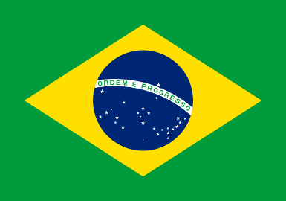

Committe: SOCHUM

Delegate: Defne Karagöz

Agenda: Counter-cultre, New Left, Anti-war Protests and Movements

Brazil is a country which is located in South America, and it is the largest country in Latin America. Brazil’s capital city is Brasilia. With all of the immigrations came into Brazil, made this country a multicultered place.

Counter-culture is a way of life that is different from the accepted social norms by the most of society and living the opposite lifestyle. In the generation which was born in 19260-1970 was called “counterculture generation” and they were transforming to not accepting the social norms and family dynamics. Media called them “hippie”, attempting to categorize the new generation, who believed that rejecting social norms was “trendy”. The Hippies, rejected the socaily accepted living lifestyle, dressing, and behaving. They wanted to live their life in peace and with freedom.

According to the UN, human have basic rights and Brazil is one of the country that entended the basic human rights “everyone has to right of life,liberty and security of the person.” Countrys around the world had to mantain their policies with incessantnesses especially military sources because of the Cold War to keeping the regime in the country. In 1960 the New Left ideology was directly against the Vietnam War, with this ideology people did protests to stop the war which they thought war was unnecessary. While The New Left movements started getting more actions, eccentrically there wasn’t a political demonstration there was a protestation for anti-war movements. The New Left didn’t fall into line like before, there was a inoppressive enviroment. The New Left had it is unique style, they’re first aim was sowing the war. Brazil is a country which is against the war, and a multicultreled place that people had rights and had freedom. Brazil bend towards to having a autarky policy, believing that every person should have the opportunity to earn money.

<https://www.ohchr.org/Documents/Publications/Compilation1.1en.pdf>

<https://digitallibrary.un.org/record/220212>

<https://www.bbc.co.uk/programmes/w3cszz6c>