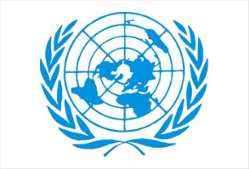
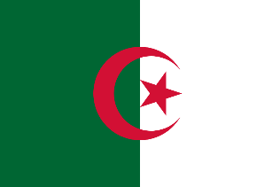
Country : Algeria
Committee : The World Health Organization (WHO)
Agenda Item : Addressing Health Issues Caused by Air Pollution

Algeria, has not been spared the problem of pollution like more other countries. The situation has become worse by waste and garbage spread everywhere, in urban, rural areas and in industiral facilities which cause serious environmental and public health problems. Pollution rates continue to rise because of toxic gases, smoke chemicalsfrom factories, and CO2 emissions from vehicles. In addition to this uncontrolled use of fertilizers and pesticides have increased air pollution and food contamination.
According to a 2018 study by Harvard University, Algeria is among the countries at highest risk. They say our country is dependent on the foods that lose nutrients when the CO2 in the air increases. Another report which was published 2016 says that the rate of mortality was 10%in 2013 because of pollution.ince 1983 several laws have been set to protect the environment and natural resources. We tried various environmental aspects and procedures, with fines and other penalties on polluters. Although many environmental laws and plans have been passed to protect the enviromnent, pollution is still a major concern in big cities. According to the official datas because 50 per cent of the cases of bronchitis, asthma, lung cancer and others are caused by environmental pollution. So we have to spend billions of dollars only to cure people.
Recently, we have taken important steps to do more climate change and environmental issues. We have signed Paris Agreement and we have promised reducing greenhouse gas emissions by 7% with spending our own money, and by up to 22% with international support by 2030. We have also become amember of the Global Green Growth Institute in August 2025 and we promised to develop a low-carbon, climate-resilient model. This step shows our strong desire for sustainable development and green economy. We are actively trying to do our best in renewable energy, sustainable land use, food and water security, waste management, and a national green hydrogen strategy.
We believe that international cooperation, the knowledge exchange and experience are essential to achieving our goals. We want to establish strong partnerships so that focus more on water security, green hydrogen and renewable energy. We are readyto share our expertise to support national strategies and, make a meaningful contribution to regional and global climate change solutions.
REFERENCES:
1. Algeria become 52. Member, https://gggi.org
2. https://www.undp.org
3. Pollution in Algeria, https://fanack.com/

