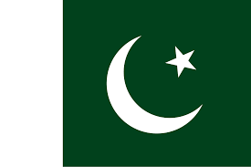
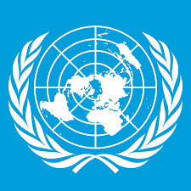
Committee: SOCHUM
Country: Islamic Republic of Pakista
Agenda Item: Ensuring Access to Education for Refugee Children

Our country was established in 1947 after the II.World War and it is famous for its diverse geography, stretching from the Himalayan mountain range in the north to the plains in the south. In addition, we have a rich cultural heritage formed from ancient civilizations lived around, Islamic traditions, and our multilingual and multiethnic population. We are one of the world's largest country with our 256 million people..
Our education policies for children of refugees are very simple: each child has a right to education. Education in our country is free for all children between 5 to 16 years old. Refugee children with PoR or ACC can go to public schools. Our government has explained to the schools exactly that these documents will be accepted. Refugee children study our curriculum, and hence their certificates are recognized.
In addition, we are working with UNHCR to implement special education programs. Examples of these programs include schools in refugee villages, learning centers in the community and at the household level, and teacher education programs based on national curriculum standards. In higher education institutions, refugees can sit for competitive exams and apply for admission using their refugee status documents. In this respect, we participate in scholarship programs such as DAFI to enable additional refugees to access education. We are revising our guidelines to make it easier for refugees. For instance, in some of these regions where institutions asked for birth certificates, we advise them to accept PoR and ACC in lieu of birth certificates. Additionally, we make sure that children with disabilities in refugee status have equal access to education without requiring them to have medical documents.
In summary, our country achieved a lot in this problem across the whole world. Our government’s strategy is to make education accessible to all refugee children. Our goal is to remove any barriers so students can join school without difficulty and make them secure in their educational surroundings. Through this, we can help refugee children learn and grow. Of course, an education from refugee children must be qualified, and basically, our goal is a fair treatment in education.
References:
- Wikipedia
- https://www.unesco.org/en/emergencies/education/data/refugees/pakistan
- https://www.unhcr.org/pk/news/stories/government-unhcr-verify-1-3-million-afghan-refugees-pakistan.html

