
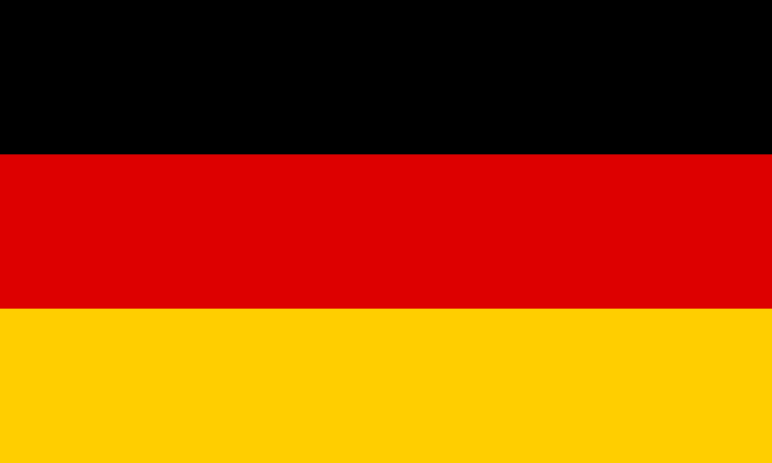
Country: Germany
Committee: The World Health Organization (WHO)
Agenda Item: Addressing Health Issues Caused by Air Pollution

Germany is located in the middle of Europe, not ot mention we are one of the most developed countries in the EU. Our help in medical vaccines and developments in medical fields, such as one of the more recent COVID-19 vaccines, was found in Germany(?).
We strongly believe air pollution causes one of the most risky health problems, such as strokes, aggravated asthma and lower respiratory infections. This affects hundreds, if not millions, of lives.
This causes casualties around the world, and around 28 thousand casualties in 2020 alone. Since we have one of the more factories and produce more air pollution than normals its exteremly important for us to reduce the pollution to make our air quality better, and we are succeeding, as it was ranked “Moderate” or “Good” by the AQI (Air Quality Institute)
Our various policies aim to reduce this pollution level and eliminate pollution for the betterment of the people and the earth. One of these is the Ta Luft program, which Germany has been using since the 1960s to protect their air quality. Air pollution control has historically been monitored under this regulation. In addition, the Federal Climate Change Action Act, which came into force in 2019, aims to reduce greenhouse gas emissions by at least 65% by 2030 compared to 1990 levels and to achieve carbon neutrality by 2045.
As a result, we are making progress on this important issue. Such as, in 1990, the air pollution level was 22.5, but in 2020, it was 10.3, which is a significant improvement for us. We will continue to make progress, and we believe that by strengthening international relations and working with all countries on solutions to this important issue, we can carefully find solutions that can help the current and the next generations for as long as needed.

References: https://www.google.com/
https://www.wikipedia.org/

