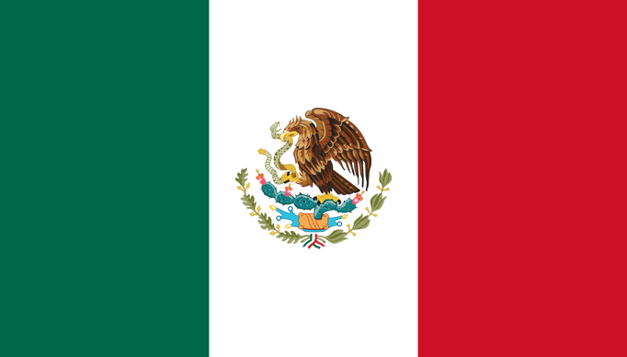
Committee: The Commission on Narcotic Drugs (CND)
Country: United Mexican States
Agenda Item: Strengthening International Cooperation to Combat Drug Trafficking and Narco-Terrorism

The Commission on Narcotic Drugs, commonly referred to as the CND, was created in 1946 by resolution 9 of the Economic and Social Council (ECOSOC). Its primary role is to aid the ECOSOC in overseeing the enforcement of international drug control treaties. The CND conducts assessments and studies on the worldwide drug situation, with a focus on addressing drug abuse prevention, drug user rehabilitation, and the distribution and trafficking of illegal drugs. Resolutions and decisions are used by the CND to take action on these issues.

Mexico has long been grappling with the pervasive issue of narcotic activities, as the country serves as a key battleground in the global war against drug trafficking. The illicit drug trade, dominated by powerful cartels, has been a persistent challenge, fueled by factors such as poverty, corruption, and a complex geopolitical landscape. Mexico's strategic location as a major transit country for narcotics destined for the lucrative U.S. market has led to intense and often violent competition among rival drug cartels. The government's efforts to combat these activities have been met with significant challenges, including the infiltration of law enforcement agencies and the judiciary by drug cartels. Despite ongoing counter-narcotics initiatives, the issue remains deeply entrenched, posing serious social, economic, and security concerns for Mexico and its neighboring countries. International collaboration and comprehensive strategies that address root causes are crucial for addressing the complex web of challenges associated with narcotic activities in Mexico.

Addressing Mexico's narcotic problem requires a multifaceted approach that goes beyond traditional law enforcement measures. One crucial aspect is strengthening institutional frameworks to combat corruption and enhance the rule of law. Mexico must invest in comprehensive and sustainable socio-economic development initiatives in regions most affected by drug-related activities, providing alternative livelihoods and opportunities for vulnerable populations. International cooperation is vital, with countries working collaboratively to disrupt transnational drug trafficking networks. Additionally, improving intelligence-sharing mechanisms and enhancing border security can help prevent the illegal flow of narcotics. Rehabilitative and preventive measures should be prioritized to address drug addiction as a public health issue, offering treatment and support for individuals struggling with substance abuse. Engaging communities through education and awareness programs can also play a pivotal role in changing social norms and attitudes towards drug consumption. Ultimately, a combination of targeted law enforcement, socio-economic development, international collaboration, and public health initiatives is essential to create a sustainable and effective solution to Mexico's narcotic problem.

In conclusion, the Commission on Narcotic Organizations in Mexico faces a formidable task in addressing the multifaceted challenges posed by the pervasive presence of drug cartels and the illicit drug trade. The complexity of this issue demands not only a focused and robust law enforcement response but also a comprehensive approach that tackles the root causes, including socio-economic disparities, corruption, and weak institutional frameworks.

