Republic of Zimbabwe 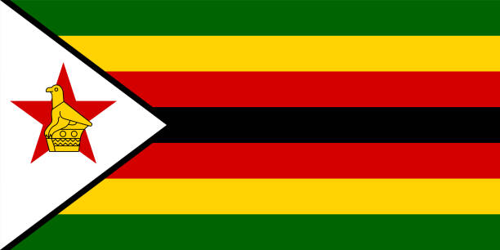

Committe:UNICEF

Agenda İtem: Child Labor

Child labor is the early entry of children into the labor market, which casts a shadow over the childhood of young souls and affects their health and future. If this situation is not prevented, it will create major problems for society in the future. Because the future of young souls is our future too. While the rate of child labor has been decreasing every year, it has increased in recent years. İt is estimated that the rate of child workers between the ages of 15-17 in Zimbabwe will be 44 percent in 2023. 40 percent of children in Zimbabwe cannot receive education.

Some of the measures to be taken to prevent child labor:

Economic development: With economic development, poverty is reduced and the rate of children receiving education may increase.

Access to Education: By increasing access to education, children will avoid early participation in the labor market.

Ending the economic crisis: Ending the economic crisis will ease the burden on families. This way, children will not need to work.

Social support programs and raising awareness in society are other important methods.

However, the challenges faced in combating child labor in countries such as Zimbabwe are often complex and multi-layered. Poverty, lack of education, unemployment and other social factors are interconnected and solving these problems requires a broad plan. Therefore, solidarity between the international community, government and non-governmental organizations is important for sustainable solutions.

Therefore, in order to end child labor, inflation and economic crises must be intervened as a priority. Inflation in Zimbabwe is 231 million percent and this rate is increasing. Zimbabwe is under a heavy burden due to the sanctions imposed by the USA and the UK. In Zimbabwe, less than 60 percent of children live below the hunger line. It is necessary to take into account that these sanctions, imposed for certain reasons, do not change the leader of the country, but only affect children and the poor.