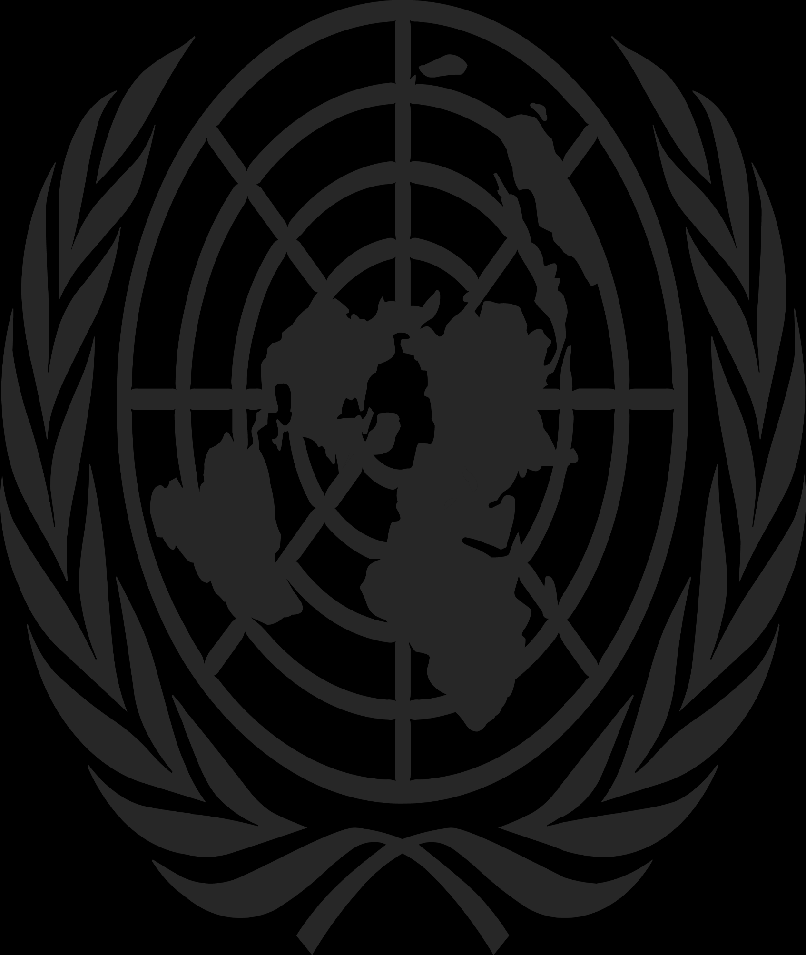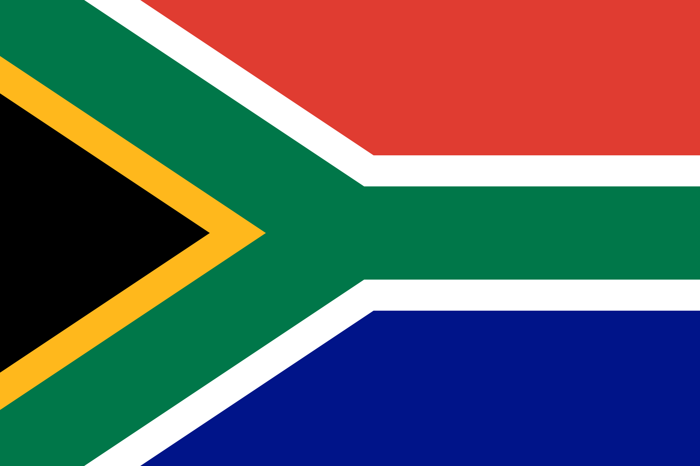 **Committee Name**: United Nations Office on Drugs and Crime

**Topic/Agenda**: Modern Human Trafficking in Arabian and African Regions

**Country**: South Africa

**Delegate’s Name**: Eşref Yiğit Bozbaş

‘’Modern Day Slavery and Human Trafficking’’ can be observed in any country at any time in the modern world. This illegal immigration and trafficking exploit its victims through forced labor, domestic servitude,and sex work. Factors that push people to get involved with illegal immigration are poverty, unemployment, displacement, drug abuse, and the list continues. Victims are specifically from African, Arabian, and Eastern Asian regions immigrating to European countries mostly.

As the Republic of South Africa, we pledge to cooperate and work sufficiently to fight trafficking in persons and provide resources and services to the victims while making sure the traffickers that are responsible get punished.  
  
**Cause**

As can be seen in official reports, the main issues that cause trafficking and exploitation in persons are poverty, unemployment, drug abuse, displacement, romantic relations, the pursuit of new career opportunities, bonded labor/ debt bondage, and lack of services preventing illegal immigration and enslavement.  
  
**Current Policy**The government of South Africa established law enforcement against human trafficking and criminalized sexual exploitation and child trafficking. Full legislation based on UN Trafficking Protocol (Palermo) has been drafted, a ‘’Trafficking Desk’’ established within the Organized Crime Unit of the South African Police Services, traffickers sentenced to significant prison terms, including government officials complicit in human trafficking, and increased the identification process of victims and shelters.

However, according to the universal press and CIA reports, an expansion of capacity or an increasing effort in anti-trafficking cannot be seen. Due to this lack of services in coordination in identifying, certifying, and securing the victims, our government failed to promulgate implementing regulations for the 2013 Prevention and Combating of Trafficking in Person Act’s immigration provisions and policies, causing foreign immigrants to get victimized due to the unable access to the immigration remedies and lifting South Africa on Tier 2 Watch List.  
  
**Possible Solutions**\*Increasing surveillance and expanding our budget on victim identification is our priority since we all know the main problem here is not our government's policies but a lack of resources. Increasing outreach and awareness about forced labor, engagement in commercial sex, and foreign migrants participating in agricultural communities for public health is another policy on our to-do list. Collaboration between law enforcement is another motion we would like to propose.

*Since South Africa and the border regions of S.A. is the starting point of the issue we refer to as ‘’Football Trafficking’’ we would like to establish a new policy by cooperating with Türkiye and other European countries offering the surveillance of scouts and clubs involved in illegal immigration and fraud. While coming up with this motion we are well aware of the current immigration problems in those countries caused by the displacement in the middle east region, offering our intelligence and all the financial help that our country is capable of.

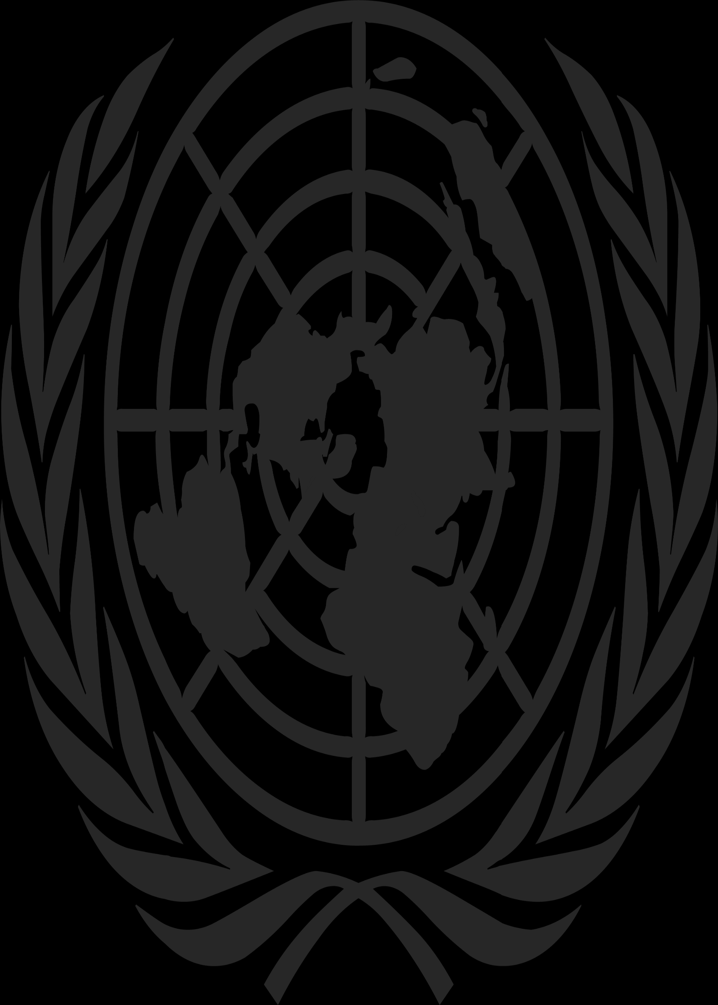**Agenda 2: Effects of Drug Decriminalization on Drug Abuse**Usage of illegal substances is considered a crime in many countries including the Republic of South Africa. Decriminalization of drug abuse can be described as reducing the penalties for people facing punishment and regaining them to society. Also, this act has positive effects such as creating a profile that is suitable for addressing resources of public health services (including identifying drug usage as a health issue) on people, changing the general approach of people on drug usage, and addressing the resources of the penal system to more serious crimes.

Decriminalization may also have effects like provoking people to drug usage, increasing the number of people who are suffering from drug abuse by letting them use drugs again (if drug usage is considered a health problem, a person can deny remedy), it may also cause a dysfunction in social life in a country. In conclusion, it is a controversial subject depending on a government's policy on drugs and public awareness.  
  
  
**Current Policy of South Africa on Drug Abuse**Under the 1992 Drugs and Drug Trafficking Act, the South African Police Service is given the lead on the enforcement side primarily in detecting and investigating drug crimes. According to the test results, 15 percent of South Africa’s population is struggling with drug abuse causing poverty, dysfunction in family structure, and provocation of involvement in human trafficking. South Africa is facing a drug abuse problem, especially in urban regions, and it is reported that our country is a distribution and production center for specific materials used in illicit drugs.

We also would like to mention that drug abuse is one of the methods that human traffickers use to push and force South African people into domestic servitude and sex work is a fact that needs to be considered when discussing the decriminalization of drug usage.  
  
  
**Point of View and Possible Solutions**\*Since our country needs innovation and expansion on addressing public health resources to people we do not think we can create a new policy that includes rehabilitation and providing mental treatment for victims of drug abuse. It is also a dangerous act because the smuggling of drugs and drug abuse is a part of the huge human trafficking problem that we are working on.

*A motion that includes the prohibition of drug usage and an expansion of a budget about increasing public awareness and rehabilitation services provided to prisoners may be acknowledged by The Republic of South Africa. We think our country is not ready for the possible outcomes of decriminalization of drug abuse on public health and fighting drug crimes.  
  
  
  
  
  
  
 **Sincerely, Delegation of South Africa**