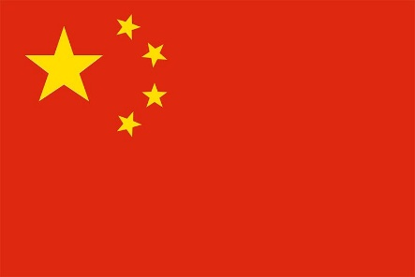
Country: China
Committee: Special, Political and Decolonization Committee (SPECPOL)
Topic: The Somalia Conflict: Implications for Peacemaking and Peacekeeping Efforts
China remains firm in striving to safeguard world peace and development, including conflict-stricken African countries like Somalia. China will not tread the old path of war, colonization and plunder taken by some countries. The brutal and blood-stained path toward a better life at the expense of others has caused great suffering for people in developing nations, including China. China stands out firmly against all forms of hegemonism and power politics, the Cold War mentality, interference in other countries’ internal affairs, and double standards.
China helps African countries constantly strengthen energy, transportation and other infrastructure construction and industrial and agricultural development. China-Africa cooperation is not an empty slogan, nor a game of numbers. It is demonstrated by tangible achievements on the African continent and the benefits delivered to the African people. In the past two decades alone, China has helped Africa build and upgrade more than 10,000 kilometers of railways, nearly 100,000 kilometers of roads, nearly 1000 bridges and 100 ports. It has laid more than 200,000 kilometers of optical fiber in Africa, and helped 6 million African households access broadband Internet. China has also helped Africa build a large number of hospitals and schools.
Somalia is suffering from an exceptional drought. Over eight million people are in urgent need of humanitarian assistance, while over 1.3 million people are displaced. China calls on the international community to increase its humanitarian support to Somalia, honor assistant commitments, and ensure timely provision of humanitarian funds. At the same time, the Somali Government should do more, including reducing bureaucratic restrictions on humanitarian work and improving humanitarian access, so as to create a solid basis for meeting the security and development needs of its people. In particular, issues such as forced recruitment, indiscriminate attacks, and destruction of infrastructure require our serious attention. China appeals that relevant military operations should take seriously the protection of civilians, in particular the security of the vulnerable such as women and children, and work to eliminate their negative impacts.
More than 600 years ago, Chinese navigator Zheng He arrived in Mogadoxo, that is, Mogadishu, the capital of Somalia today. Dating back hundreds of years, historical records show that the two sides had exchanges as early as the Tang Dynasty (618-907). Time and tide have changed, so has the world. Yet the traditional friendship between China and Somalia has withstood the test of time and distance. China has, and continues to provide aid for their African allies.

