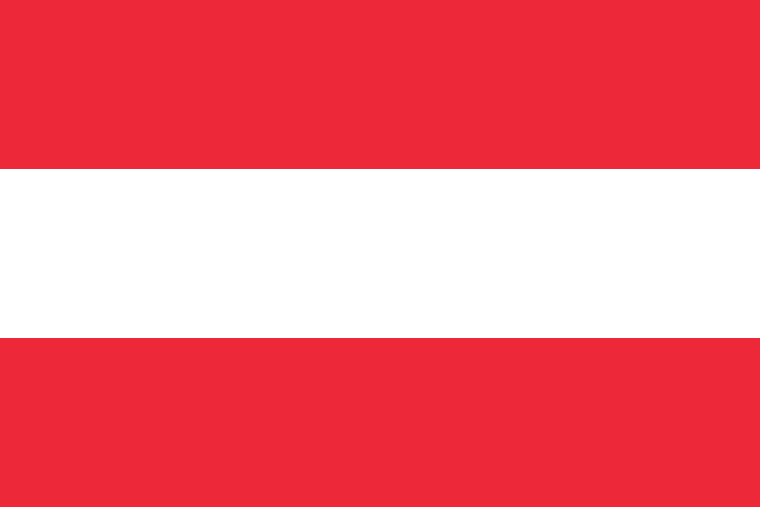
Position paper
Country: Austria
Committee:SPECPOL
About of austria: Austria is bordered to the north by the Czech Republic, to the northeast by Slovakia, to the east by Hungary, to the south by Slovenia, to the southwest by Italy, to the west by Switzerland and Liechtenstein, and to the northwest by Germany. It extends roughly 360 miles (580 km) from east to west. Austria has a population of 8,956 million
Committee: The Special Political and Decolonization Committee (SPECPOL) is one of the six main committees of the United Nations General Assembly. It was established in 1961 . Over the years, SPECPOL's mandate has expanded to include a range of political and security issues, such as disarmament, terrorism, and sustainable development.
Committee Topic: SNM declared the Republic of Somaliland an independent state of northern Somalia, the military junta ruled Somalia under the command of General Siad Barre. This uprising was known as the Somaliland War of Independence. The conflict became the focus of the larger Somali Uprising that began in 1978. The harsh policies of the Barre regime, especially the declaration of economic war against the Isaaq, the largest clan family in Somaliland, became the cause of the war. The Somali government launched a genocide against Isaaq between May 1988 and March 1989 to resolve the "Isaaq problem" amid the ongoing struggle. Barre was responsible for the deliberate bombing and bombing of important northwest cities, as well as the deliberate destruction of Isaac's homes, villages, and water supplies. The Republic of Somalia specifically targeted the civilian Isaaq tribes in Hargeisa and Burao and carried out indiscriminate artillery and aerial bombardment of the civilian Isaaq population.
Expectations: Austria doesn’t support any specific Side. We donate money with EU to Somali Republic we just want peace.
Our Solutions:
-We want to nullify terror groups.
-Children should be sent to more developed countries for education.
-We could start fundraising for Somali civil war

